LEARNER GUIDE


ANALYSE COMPLIANCE TO LEGAL REQUIREMENTS AND RECOMMEND CORRECTIVE ACTIONS

Unit Standard 252030
NQF Level 5
Credits 4
Table of Contents

1. ANALYSE COMPLIANCE TO LEGAL REQUIREMENTS AND RECOMMEND CORRECTIVE ACTIONS 3
1.1 STATUTORY LAWS 3
1.1.1 The Labour Relations Act 4
1.1.2 The Basic Conditions of Employment Act 7
1.1.3 Employment Equity Act 9
1.1.4 Skills Development Act 10
1.1.5 Skills Development Levies Act 10
1.1.6 The Protected Disclosures Act 13
1.1.7 The Companies Act 14
1.1.8 Income Tax 16
1.1.9 Employees’ tax (PAYE) 20
1.1.10 VAT 22
1.1.11 Turnover tax 24
1.1.12 UIF – Unemployment Insurance Legislation 25
1.1.13 Compensation for Occupational Injuries and Diseases Act (COIDA) 29
1.1.14 Protection of Personal Information Act (POPIA ACT) 30
1.1.15 Broad-Based Black Economic Empowerment (BBBEE) Act 32
2. INTERPRET LAWS, LEGAL DOCUMENTS, STANDARDS AND CODES OF PRACTICE RELEVANT TO THE UNIT 35
2.1 LEGAL OBLIGATIONS 35
2.2 STAKEHOLDER CONSULTATION TO OBTAIN POINT OF VIEW ON LEGAL OBLIGATIONS 37
2.3 IMPLICATIONS OF COMPLIANCE AND NON-COMPLIANCE 38
2.3.1 Compliance 38
2.3.2 Non-Compliance 41
3 ANALYSE THE COMPLIANCE TO LEGAL AND OTHER REQUIREMENTS THAT REGULATE THE UNIT 44
3.1 COMPLIANCE TO LEGAL AND OTHER REQUIREMENTS 44
3.2 THE REQUIREMENTS OF THE LABOUR RELATIONS ACT AND CODE OF GOOD PRACTICE REGARDING DISMISSAL 54
3.2.1 Code of Good Practice – Dismissal 54
3.2.2 Guidelines in cases of Dismissal for Misconduct 58
3.2.3 Guidelines in cases of Dismissal for Poor Work Performance 59
3.3 THE BASIC CONDITIONS OF EMPLOYMENT ACT 61
3.4 Who is an Employee? 68
3.5 The CCMA 70
3.6 The Employment Equity 73
3.7 Skills Development Act 76

- ANALYSE COMPLIANCE TO LEGAL REQUIREMENTS AND RECOMMEND CORRECTIVE ACTIONS

STATUTORY LAWS
Statutory laws are written laws that have been approved by a legislature (either a state or federal legislature). Statutes may require specific actions, prohibit them, act as declarations of intention or lay out the ways in which government will act in certain circumstances.
A business unit manager is expected to know where to access relevant legislation (Labour, occupational health and safety, the environment, trade constraints, financial framework, legal framework and any other areas specific to the team, department or division) when required. All legislation pertaining to the specific business should also be available to all employees within the organization. Most regulations and legislation are available on the Internet:
- Labour regulations can be found on www.labour.gov.za
- Exchange Control regulations can be found on www.resbank.co.za
- Financial regulations can be found on www.fsb.co.za
- Tax regulations can be found on www.sars.gov.za
- Workman’s compensation regulations can be found on www.wcomp.gov.za


Most of the above websites also contain links to specific industry-related legislation. When interpreting legislation, it is important for the manager to ensure that his team, business unit or department is complying with the various legislations and statutory regulations that are applicable. Compliance is either a state of being in accordance with established guidelines, specifications, or legislation or the process of becoming so. Compliance in a regulatory context is a prevalent business concern, perhaps because of an ever-increasing number of regulations and a fairly widespread lack of understanding about what is required for a company to be in compliance with new legislation.

The 15 pieces of Labour legislation that regulate employment issues are:
- The Labour Relations Act, 66, of 1995 (as amended)
- The Basic Conditions Of Employment Act, 75, of 1997 (as amended)
- Employment Equity Act, 55, of 1998
- Skills Development Act, 97 of 1998.
- The Skills Development Levies Act.
- The Protected Disclosures Act.
- Companies Act
- The Income tax Act
- Pay as you earn (PAYE)
- Value Added Tax (VAT)
- Turnover tax
- Unemployment Insurance Funds (UIF)
- Compensation for Occupational Injuries and Diseases Act (COIDA)
- POPIA ACT
- BBBEE ACT

    - The Labour Relations Act
The Labour Relations Act (LRA), which came into operation on 11 November 1996, aims to give effect to everyone’s constitutional right to fair Labour practice. The LRA confers on employees the right to join trade unions and on trade unions the right to represent their members in all employment-related matters.
The LRA provides a framework within which employees can exercise their right to strike and within which employers can exercise their right to lock out employees from the workplace.

But more importantly, the LRA confers on employees the right not to be unfairly dismissed and the right not to be subjected to unfair Labour practices by prescribing the grounds on which employees' services can be terminated, as well as the procedures to be followed before dismissal can be contemplated.

The LRA establishes the Labour Court, the Labour Appeal Court, as well as the CCMA, all tasked with adjudicating employment disputes. By imposing limits on the compensation that may be awarded to employees for unfair dismissal, the LRA also endeavors to create certainty between employers and employees.

Where a dismissal is based on the employer's operational requirements, the LRA adopts a more prescriptive approach in terms of the procedure to be adopted by the employer in order to safeguard employment as far as possible.

Although an employer is not obliged to adopt a purely checklist approach to the prescribed procedure, the employer is required to:

- Disclose to the employee, or his/her duly authorized representative, in writing, all relevant information to enable the employee to participate constructively in the process, including, for example, the reasons for the proposed dismissal, the number of employees likely to be affected, alternatives considered before proposing dismissal, the severance pay proposed, any assistance to be given to affected employees and the possibility of future employment
- Engage with the employees likely to be affected by the process in a meaningful joint consensus seeking process. If consensus cannot be reached on the need to retrench and the employer remains of the view that retrenchments are required, the employer will be entitled to nevertheless retrench its employees. In the case of large employers embarking on large- scale retrenchments, the LRA allows the employees to strike in order to oppose the pending retrenchments.

The LRA aims to encourage voluntary collective bargaining and the settlement of disputes, and does so by enhancing the powers of workplace forums designed to facilitate those objectives. We can sum up the purpose of the LRA as follows:
- Regulates the organizational rights of trade unions

- Promotes and facilitates collective bargaining at the workplace and at sectoral level
- Regulates the right to strike and the recourse to lockout in conformity with the Constitution
- Promotes employee participation in decision-making through the establishment of workplace forums
- Provides simple procedures for the resolution of Labour disputes through statutory conciliation, mediation and arbitration (for which purpose the Commission for Conciliation, Mediation and Arbitration is established), and through independent alternative dispute resolution services accredited for that purpose
- Establishes the Labour Court and Labour Appeal Court as superior courts, with exclusive jurisdiction to decide matters arising from the Act
- Provides for a simplified procedure for the registration of trade unions and employers' organizations, and to provide for their regulation to ensure democratic practices and proper financial control
- Gives effect to the public international law obligations of the Republic relating to Labour relations

Fair Labour Standards

This act regulates minimum wage, overtime rules, child Labour bans, and record keeping requirements. You will want to read through it to make sure you comply with the current regulations.
Employment relationships are built on trust and the rights of parties. Employees and employers have very specific rights in terms of common law and Labour legislation. Balancing these rights is extremely important and pivotal to a fair and successful employment relationship.
    - The Basic Conditions of Employment Act

The Act applies to all employees and employers except members of the National Defense Force, National Intelligence Agency, South African Secret Service and unpaid volunteers working for an organization with a charitable purpose.
The basic conditions of employment contained in the Act form part of the contract of employment of employees covered by the Act. Some, but not all, basic conditions of employment may be varied by individual or collective agreements in accordance with the provisions of the Act.

Purpose of this Act


The purpose of this Act is to advance economic development and social justice by fulfilling the primary objects of this Act which are:

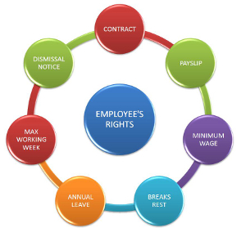
- to give effect to and regulate the right to fair Labour practices conferred by section 23(1) of the Constitution:
(i) by establishing and enforcing basic conditions of employment; and
(ii) by regulating the variation of basic conditions of employment;
(b) to give effect to obligations incurred by the Republic as a member state of the International Labour Organization.

Compensation for Occupational Injuries and Diseases Act

This Act aims to provide compensation for disablement caused by occupational injuries or diseases sustained or contracted by employees in the course of their employment, or for death resulting from such injuries or diseases; and to provide for matters connected therewith. The Compensation for Occupational Injuries and Diseases Act applies to:
- all employers; and casual and full-time workers who, as a result of a workplace accident or work-related disease: are injured, disabled, or killed; or become ill.

This excludes -

- workers who are totally or partially disabled for less than 3 days; domestic workers;
- anyone receiving military training;
- members of the South African National Defense Force, or the South African Police Service;
- any worker guilty of willful misconduct, unless they are seriously disabled or killed;
- anyone employed outside the RSA for 12 or more continuous months; and
- workers working mainly outside the RSA and only temporarily employed in the RSA.

    - Employment Equity Act

Applies to all employers and workers and protects workers and job seekers from unfair discrimination, and also provides a framework for implementing affirmative action.
The purpose of the Employment Equity Act, no 55 of 1998 is to achieve equity in the workplace by promoting equal opportunity and fair treatment in employment through elimination of unfair discrimination and implementing affirmative action measures to redress the disadvantages in employment experienced by designated groups, in order to ensure equitable representation in all occupational categories and levels in the workforce.
This Act provides for additional reporting requirements employers with the additional burden of submitting an Employment Equity Report.

- Occupational Health and Safety Act
Provide for the health and safety of persons at work and for the health and safety of persons in connection with the activities of persons at work and to establish an advisory council for occupational health and safety.

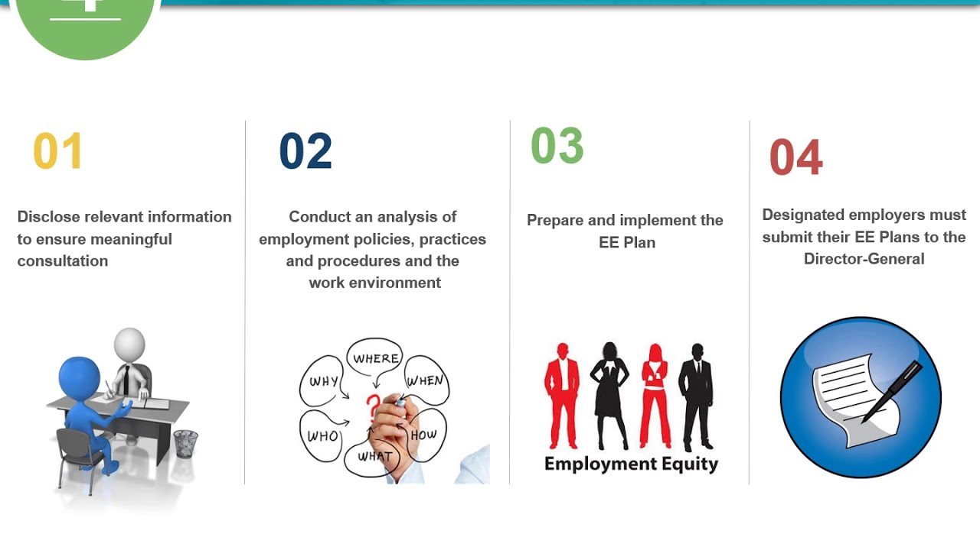
The Act is based on the principle that dangers in the workplace must be addressed by communication and cooperation between the workers and the employer. The workers and the employer must share the responsibility for health and safety in the workplace. Both parties must pro-actively identify dangers and develop control measures to make the workplace safe.

In this way, the employer and the workers are involved in a system where health and safety representatives may inspect the workplace regularly and then report to a health and safety committee, who in turn may submit recommendations to the employer.

Skills Development Act

The Skills Development Act aims to develop the skills of the South African workforce and to improve the quality of life of workers and their prospects of work. To improve productivity in the workplace and the competitiveness of employers and to promote self-employment.

This Act was introduced by government in 1998, in the midst of high levels of unemployment, low levels of investment in the South African Labour market, pronounced disparities in income distribution, inequality of opportunity as a result of apartheid and poverty. Through this Act, the government aimed to address two main priorities, i.e., the need to improve skills and increase productivity in order to compete successfully in the global economy, and the need to reverse apartheid imbalances and to create a more inclusive and cohesive society.

    - Skills Development Levies Act

Every employer must pay a skills development levy each month towards the National Skills fund.
The purpose of the Skills Development Levies Act

This Act regulates a compulsory levy scheme to fund education and training in businesses within various sectors in South Africa. It aims to expand the knowledge and competencies of the Labour force and in so doing increase the supply of skilled Labour in South Africa, providing for greater productivity and employability.

The criteria currently used for employers to become eligible to pay Skills Levies:
If the company has staff registered for PAYE and the annual payroll exceeds R500 000 per annum, the company must register with SARS and pay a skills levy of 1% of the monthly payroll. If the company does not fall within these criteria, it does not have to pay levies or register with SARS.

The short supply of skilled staff is a serious obstacle to the competitiveness of industry in South Africa. The levy grant scheme aims to expand the knowledge and competencies of the Labour force resulting in improvements in employability and productivity. This will be achieved through new approaches to planning for training, learning programmes, incentives and an improved employment service. If you participate fully in the scheme, you will reap the benefits of a better skilled and more productive workforce.

Claiming grants: general information
- Employers who are up-to-date with the payment of the skills levy can claim skills grants from their SETA. Their SETA is the one to which employers pay their levies.
- Each SETA will decide the dates by which applications for grants must be made. They will let employers know about these arrangements. Employers may also approach their SETA for information.
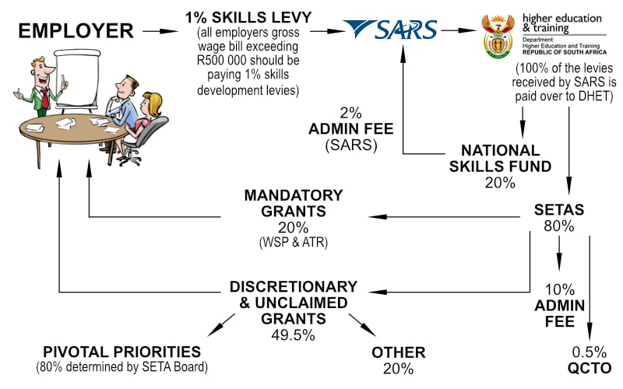
- Training providers and workers may also seek grants from a SETA. These grants may be given to projects, programmers and research activities if they support the implementation of the sector skills plan that each SETA has developed. Each SETA will publish details about the grants and how to apply for them.

Grants
There are six types of grants that an employer might claim. These are:
- a workplace skills grant;
- a workplace skills implementation grant;
- a grant towards the costs of learner ships and learner allowances
- a grant towards the costs of skills programmes;
- a grant towards the costs of providing apprenticeship training; and
- a grant towards a programme, project or research activity that helps the relevant SETA to implement its sector skills plan.

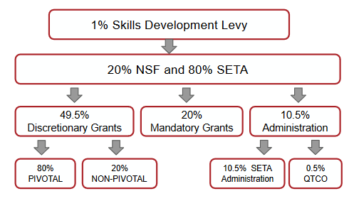
The first two grants - for the submission of a workplace skills plan, and for a subsequent implementation report on the training provided - MUST be paid by the relevant SETA as long as an employer submits the application correctly on time, as assessed by the appropriate SETA. The Regulations refer to these as mandatory grants.

The workplace skills planning grant is fixed as a percentage of the levies paid by an employer. An employer who makes an application on time and in the proper way will receive 15 per cent of the total of the levies s/he has paid. Similarly, the workplace skills implementation report will be, in 2001/2, 50 per cent of the total levies paid and in 2002/3, 45 per cent of the total levies paid.

The other grants are discretionary and a SETA may pay these. It will decide the grants it will pay on the basis of the contribution that the skills development activities being proposed will contribute to the implementation of the SETA's sector skills plan. For example, there may be a number of requests for grants to support Learnership. If a choice has to be made between a number of different applications for such grants, the SETA will make its decisions on the basis of the priorities set out in its sector skills
plan. Each SETA will determine the amounts of all the other grants. Applications for these grants MUST be made and approved by the SETA before any training or other activity starts.

The Protected Disclosures Act
The Act makes provision for procedures in terms of which employees in both the private and the public sector may disclose information regarding unlawful or irregular conduct by their employers or other employees in the employ of their employers.

It also provides for the protection of employees who make a disclosure, which is protected in terms of this Act. Criminal and other irregular conduct in organs of state and private bodies are detrimental to
good, effective, accountable and transparent governance in organs of state and open and good corporate governance in private bodies and can endanger the economic stability of the Republic and have the potential to cause social damage.


Neither the South African common law nor Statutory law makes provision for mechanisms or procedures in terms of which employees may, without fear of reprisals, disclose information relating to suspected or alleged criminal or other irregular conduct by their employers, whether in the private or the public sector. Every employer and employee have a responsibility to disclose criminal and any other irregular conduct in the workplace.

Every employer has a responsibility to take all necessary steps to ensure that employees who disclose such information are protected from any reprisals as a result of such disclosure:
This Act aims to:
- create a culture which will facilitate the disclosure of information by employees relating to criminal and other irregular conduct in the workplace in a responsible manner by providing comprehensive statutory guidelines for the disclosure of such information and protection against any reprisals as a result of such disclosures
- promote the eradication of criminal and other irregular conduct in organs of state and private bodies.

    - The Companies Act

The main features of the Companies Act, 2008 are as follows:

- It has been modernised and brought into line with international best practices. This applies in particular to public companies, communications and corporate governance. At the same time, it has been harmonised with other South African legislation, such as the Promotion of Access to Information Act (PAIA) and the Electronic Communications and Transactions (ECT) Act.

- It has been simplified and made less prescriptive to make it easier to understand and apply, in the following ways:

- It was drafted in plain language and the number of sections has been reduced from 450 to 225.
- The rules relating to pre-incorporation contracts have been simplified, making it possible for any person to enter into a pre-incorporation contract.
- Fewer statutory forms are required to incorporate a company. Rather than a memorandum and articles of association, a company’s constitutional documents will now consist of one document only, the Memorandum of Incorporation (MoI).
The MoI sets out the rights, duties and responsibilities of shareholders, directors and others in relation to the company. A company may alter certain provisions of the Act in its MoI, but there are specific provisions that may not be altered that apply notwithstanding the provisions of the Memorandum of Incorporation. In this way, certain protections are built into the Act. All current articles and memoranda of association will automatically be converted to an MoI.
- Companies are allowed to change certain requirements according to their own circumstances – in addition to the MoI, companies can now make certain governance rules themselves.
- Different types of companies must comply with different rules. This means smaller companies have less arduous responsibilities than large public companies when it comes to corporate governance and financial reporting. For instance, smaller companies will be subject to less taxing financial reporting standards than larger companies.

- The regulatory burden on companies has been reduced, but there are stricter accountability and transparency requirements for state-owned and public companies. Shareholders have extensive rights to obtain information from the company, including access to the securities register and minutes of directors’ meetings. Greater director accountability and the appropriate participation of all stakeholders ensure improved transparency.


- High standards of corporate governance are encouraged, with minimum accounting standards having been set for annual reports. So too, there are stricter provisions governing directors’ conduct and liability, and their common law duties and liabilities have now been codified. A new feature is that an act of a company is not void solely because the company did not have the capacity to do the act or the directors did not have the authority to perform the act on behalf of the company. No person may rely on this lack of capacity, power or authority in legal proceedings, except in certain specified circumstances. A company is specifically prohibited from reckless, negligent or fraudulent trading, and persons who were knowingly party to such conduct are guilty of an offence.

- The Act contains new structural arrangements, with the introduction of new regulatory institutions and the transformation of others. Companies are now classified as either profit or non-profit companies.

- Take-overs and fundamental transactions receive greater attention, with radical changes to the take-over provisions contained in the Companies Act, 1973. This applies particularly with regard to minority shareholding and appraisal rights for dissenting minority shareholders. New rules relate mergers and amalgamations, allowing two companies to merge into one entity, provided that the solvency and liquidity test is satisfied and certain approvals are obtained.

- Capital maintenance will now be based on solvency and liquidity rather than a minimum amount of share capital consisting of par value shares and nominal value shares.

- The concept of business rescue is broadened and formalised, and provision is made for a modern business rescue regime. Schemes of arrangement are dealt with separately under the Act.

- There is a move towards the decriminalisation of company law and the establishment of bodies for the effective enforcement of the legislation. However, minority shareholders and other stakeholders, such as employees, will have better protection, powers and remedies under the Act, including the ability to bring class actions.

    - Income Tax

What is income tax?

Income tax is a tax levied on all income and profit received by a taxpayer (which includes individuals, companies and trusts). It is the national government’s main source of income and is imposed by the Income Tax Act No. 58 of 1962.
The form of tax that people generally associate with the concept of income tax is “normal” income tax. But the Income Tax Act is also the source of a number of other taxes that, although they have their own particular names, still form part of the income tax system. A few examples of taxes which may affect taxpayers are capital gains tax and donations tax. The Act also establishes a few methods of paying income tax – namely SITE, PAYE and provisional tax.

How is income tax collected?

The year of assessment
The year of assessment for taxpayers covers a period of 12 months. For individuals and trusts, the commencement date of the year of assessment starts on 1 March and ends on the 28/29 February each year. For Companies and Close Corporations, the year of assessment is the applicable financial year.
Income tax returns are available annually after the end of each year of assessment to registered taxpayers, and must be completed and submitted to SARS each year.
The “Tax Season” commences 1 July each year, and the deadlines for the submission of returns are:
- Individual (ITR12) and Trust (IT12TR) returns (non-provisional taxpayers): Last working day of September for postal submission (the paper version) that can be posted or submitted at your local SARS branch in the designated drop box; or
- The last working day in November for eFiling via your PC or laptop or done electronically by a SARS consultant at a SARS branch. Please note that for the 2009/2010 year of assessment, SARS has announced the 26th November 2010 as the deadline for electronic submissions of Income Tax Returns.
- Individual (ITR12) and Trust (IT12TR) returns (provisional taxpayers): Provisional taxpayers have until the 31 January 2011 to submit their completed ITR12 income return to SARS.
- Company/CC (IT14) returns: Must be completed and submitted within 12 months after the financial year end of the company/close corporation.

The assessment by SARS
From the information furnished in the income tax return, SARS will issue an assessment showing either tax due or refundable, if applicable.

Who needs to register for income tax?
The Minister announced “as from September this year SARS will require all those receiving any form of employment income – including those below the tax threshold – to be registered with SARS to help reduce the scope for non-compliance.
Who needs to submit a completed and signed income tax return to SARS?
Where taxpayers receive remuneration less than R120 000, taxpayers may elect not to submit an income tax return, provided the following criteria are met:
- Remuneration is from a single employer;
- Remuneration is for a full year of assessment (1 March – 28/29 February); and
- No allowance was paid, from which PAYE was not deducted in full with regards to travel allowance.
What is SITE, PAYE and provisional tax?

The final income tax payable by a taxpayer can only be calculated once the total taxable income earned by the individual for the full year of assessment has been determined. This is normally only done after the end of the year of assessment, once a taxpayer’s income tax return has been processed and an assessment is issued.
However, it would be impractical to expect taxpayers to pay tax as a large lump sum once a year. As a result, the Income Tax Act has created three mechanisms to solve this problem: SITE, PAYE, and provisional tax. In this way, income tax is collected as soon as the taxpayer has earned the income and is offset against the final income tax that is due on assessment.
Employees’ tax
SITE and PAYE are the two elements of employee’s tax. Employees’ tax is the tax that employers must deduct from the employment income of employees – such as salaries, wages and bonuses – and pay over to SARS monthly. It is withheld daily, weekly, or monthly, when these amounts are paid or become payable to the employees.
An employer must issue an employee with a receipt known as an employees’ tax certificate (an IRP5/IT3(a)) if SITE or PAYE have been deducted. This discloses the total employment income earned for the year of assessment and the total SITE and/or PAYE deducted and paid to SARS.

Standard Income Tax on Employees
Standard Income Tax on Employees, or SITE, is not a separate tax. It is merely a method that means employees who earn less than a certain amount pay income tax as a full and finial liability on the information to the specific employer. SITE generally applies to individuals:
- whose net remuneration does not exceed R120 000 annually;
- who do not receive a traveling allowance; and
- who do not receive any other income?

Pay-As-You-Earn
Pay-As-You-Earn, or PAYE, ensure that an employee’s income tax liability is settled in a continuing fashion, at the same time that the income is earned. The advantage of this is that the tax liability for the year is settled over the course of the whole year of assessment. Refer to the PAYE page for more information.


Provisional tax
Provisional tax allows taxpayers to provide for their final tax liability by paying two amounts in the course of the year of assessment. But the final liability is determined upon assessment.
Provisional tax payments – which are made six months after the beginning of a year of assessment, as well as at the end of it – represent tax on anticipated income. Provisional tax estimates and payments are made on IRP6 forms. What are the steps in calculating the income tax owed?
The Income Tax Act No. 58 of 1962 sets out a series of steps to be followed in calculating a taxpayer’s “taxable income”. This then forms the foundation on which tax liability is calculated. These steps are briefly set out below and are tackled in greater detail in the explanations that follow.
- Determine gross income
First determine your total receipts and accruals, or total income. These concepts are not contained in the Act, but they are implied by the wording of the definition of “gross income” in Section 1 of the Income Tax Act.
Deduct from “total income” those amounts that are excluded from the ambit of the definition of “gross income”. In other words, exclude accruals or receipts:
- that are from a source outside South Africa for non-residents; or
- that is of a capital nature.
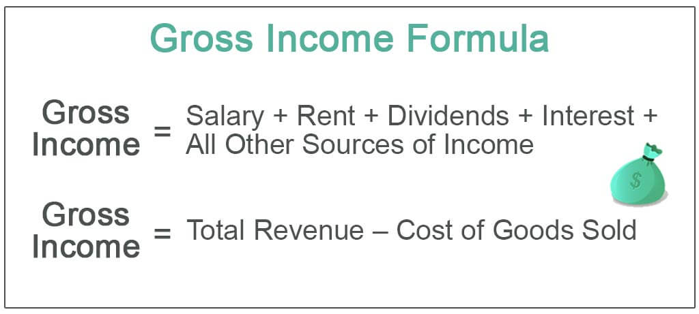
Gross income of residents for any person who is a resident, gross income is the total amount of worldwide income, in cash or otherwise, received by or accrued to or in favour of that person.
Gross income of non-residents for any person who is not a resident, gross income is the total amount of income, in cash or otherwise, received by or accrued to or in favour of that person from a source within or deemed to be within South Africa during the year of assessment.
Capital receipts and accruals Receipts or accruals of a capital nature are generally excluded from gross income as the Eighth Schedule covers these as capital gains and losses.
However, certain other receipts and accruals are specifically included in gross income, regardless of their nature. A taxpayer needs to include in gross income:
- Deduct exempt income
“Gross income” minus the exemptions set out in Section 10 is equal to “income”. A taxpayer’s “income” is therefore calculated by deducting from the taxpayer’s gross income all amounts that are exempt from tax.
- Deduct allowable deductions
The next step is to subtract certain allowable deductions from “income”, then add taxable gains and then subtract the other deductions, which leaves “taxable income”.
Deductions include:
- general deductions that qualify in terms of the general deduction’s formula
- specific deductions
- allowances and other special deductions and rulings

- Multiply ‘taxable income’ by tax rate
Once taxable income has been determined, the applicable tax rate is applied to determine tax liability. Individuals are considered “persons other than companies” and are taxed on a sliding scale.
- Subtract rebates
The taxable income multiplied by the tax rate will leave a certain amount, from which must be subtracted:
- rebates for natural persons and
- any applicable rebates for foreign taxes allowed by double-taxation agreements.
    - Employees’ tax (PAYE)

The purpose of PAYE is to ensure that an employee’s income tax liability calculated on remuneration is settled at the same time that the remuneration is earned. The advantage of
this system is that the liability for the year of assessment is settled over the course of that whole year.
Every employer who pays or becomes liable to pay an amount by way of remuneration is
obliged to deduct PAYE, if applicable, from that amount. The PAYE deducted must be paid over to SARS within seven days after the end of the month during which such deduction was made. The deduction is determined according to tax deduction tables.


- Remuneration paid or payable to employees

Remuneration paid or payable by employers to their employees in excess of the relevant
income tax threshold is subject to the deduction of PAYE.
Employees’ tax certificates (IRP5s) are issued to employees from whose remuneration PAYE has been deducted. These certificates reflect a breakdown of remuneration received,
deductions made from the remuneration and PAYE deducted.

An employer must provide an employee with an IT
- certificate in respect of taxable benefits and remuneration from which PAYE was not deducted.

- Remuneration paid or payable to directors

The remuneration of directors of companies (including individuals in close corporations
performing similar functions) is subject to the deduction of PAYE. However, if the director is a non-executive director, amounts received in that capacity for services rendered as a board
member is not “remuneration”, and are not subject to the deduction of PAYE.

- Payments to personal service providers

A personal service provider is any company or trust of which any service rendered on behalf of the company or trust to a client of the company or trust is rendered personally by any person who is a connected person in relation to such company or trust, and any one of three
conditions as set out in the definition of “personal service provider”.


Should that company or trust employ three or more full-time employees (excluding
shareholders or the settlor or any beneficiary of the trust or any person that is a connected
person in relation to that person) throughout the year of assessment and the employees are
engaged in the business of the company in rendering the specific service, that company or
trust will not be regarded as a personal service provider.

Payments made to a personal service provider are subject to the deduction of PAYE. For VAT purposes, any payment made to a personal service provider who is carrying on an enterprise will be subject to VAT at the standard rate. This rule applies even if such payments have been subject to the deduction of PAYE.

- Payments to labour brokers

A labour broker is any natural person who conducts or carries on any business and who for
reward, provides a client of the business with other persons to render a service or perform
work for such client or procures such other persons for the client, but does not personally
provide the service or perform the work, for which service or work these other persons are remunerated by the client.

Employers are required to deduct PAYE from all payments made to a labour broker, unless
the labour broker is in possession of a valid exemption certificate issued by SARS.
Remuneration paid to persons who render services to or on behalf of a labour broker is subject to the deduction of PAYE by the labour broker.
For VAT purposes, the payments made to a labour broker who is carrying on enterprise are subject to tax at standard rate and the full amount received is treated as consideration despite the PAYE being deducted on that full amount.

- Services rendered by independent contractors

The concept of an independent trader or independent contractor remains one of the more
contentious features of the Fourth Schedule.

An amount paid or payable for services rendered or to be rendered by a person in the course of a trade carried on by this person independently of the party by whom the amount is paid or payable and to whom the services are rendered or are to be rendered is excluded from remuneration for PAYE purposes.
An amount paid to a person who is deemed not to carry on a trade independently will constitute “remuneration” as defined in paragraph 1 of the Fourth Schedule and will be subject to the deduction of PAYE.

For VAT purposes, an independent contractor who carries on an enterprise is liable to register as a VAT vendor if the registration threshold of R1 million is exceeded.
    - VAT

What is VAT?

Value-Added Tax is commonly known as VAT. VAT is an indirect tax on the consumption of goods and services in the economy. Revenue is raised for government by requiring a business, that carries on an enterprise (as defined in section 1(1) of the VAT Act), to register for VAT. In doing so, the business will charge VAT on supplies of goods and services made by it, on the importation of goods and on imported services (subject to certain conditions). The business will also be entitled to deduct any VAT charged to it, or under limited circumstances from a business that is not registered for VAT, in respect of a supply made to it. VAT is therefore non-cumulative, meaning that a credit/deduction is allowed for VAT paid in previous stages, within the production and distribution chain. The business is required to pay the difference between the VAT charged by it and the VAT charged to it, or claim a VAT refund where the VAT charged to it exceeds the VAT charged by it.
VAT is therefore, charged at each stage of the production and distribution process and it is proportional to the price charged for the goods and services.
The standard rate of VAT increased from 14% to 15% from 1 April 2018. There is a limited range of goods and services which are subject to VAT at the zero rate or are exempt from VAT.

Who should register for VAT?
Any person that carries on an enterprise, as defined in section 1(1) of the VAT Act, may qualify to register for VAT. A person is a defined term and includes a company, individual, partnership, trust fund, and a municipality. In order to register, follow the application process as detailed on our page how to register for VAT.
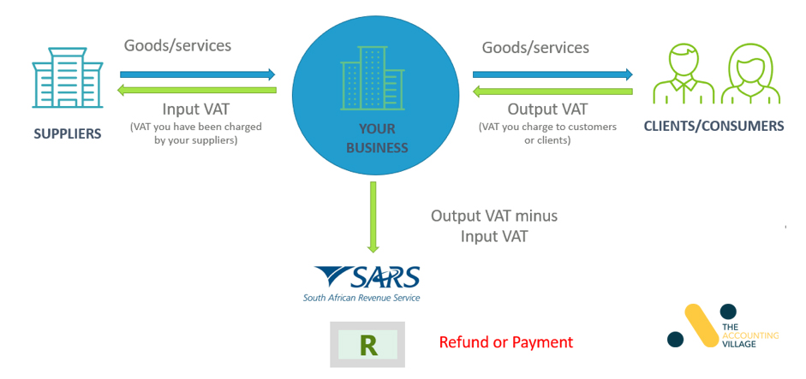
It is compulsory for a person to register for VAT if the value of taxable supplies made or to be made, is in excess of R1 million in any consecutive twelve-month period.
A person may also choose to register voluntarily if the value of taxable supplies made, or to be made, is not in excess of R1 million in any consecutive twelve-month period.
There are five categories of voluntary registrations:
- The first category applies to a specific type of person where there is no threshold for the value of taxable supplies.
- The second category applies to a person that has made R50 000 in the past period of twelve months.
- The third category applies to a person where the value of taxable supplies has not exceeded R50 000 and the conditions for registration are listed in a Regulation.
- The fourth category applies to a person that has acquired a business as a going concern.
- The fifth category applies to a person that carries on a specific nature of activity as listed in a Regulation. In addition, there are other general requirements that must also be met for a voluntarily registration for VAT.
A person who is registered (under compulsory or voluntary registration) or required to be registered (under a compulsory registration) for VAT is referred to as a vendor.
You can register once for all different tax types using the client information system.

When should I submit VAT returns and make payments?
A vendor is required to submit VAT returns and make payments of the VAT liabilities (or claim a VAT refund) on or before the 25th day or the last business day of the month following the month in which the vendor’s tax period ends. If the 25th day is not a business day, the day for submitting a return and making payment will be the business day preceding such day. Late payments of VAT will attract a penalty and interest.
Payment method | VAT return due date | Payment due date
Payments at ABSA, Albaraka Bank Limited, Access Bank (previously Grobank), FNB, HBZ Bank LTD, Nedbank and Standard Bank. | 25th | 25th
Electronic Fund Transfers (including internet banking) | 25th | 25th
eFiling of return and payment via either SARS eFiling or Electronic Funds Transfers (internet banking) | Last business day | Last business day

    - Turnover tax

As part of government’s broader mandate to encourage entrepreneurship and create an enabling environment for small businesses to survive and grow, a presumptive tax was introduced to reduce the tax compliance burden on micro businesses. Turnover tax is available to micro businesses of sole proprietors, partnerships and companies.

The turnover tax system is essentially an alternative to the current income tax regime provided for in the Act. A qualifying micro business may choose to register for VAT and turnover tax, provided that all the conditions for voluntarily VAT registration are met.

A person qualifies as a micro business if that person is –
- a natural person (or the deceased or insolvent estate of a natural person which was a registered micro business at the time of death of insolvency) or company; and
- the qualifying turnover of that person for the year of assessment does not exceed R1 million.

Turnover tax is a single tax, replacing normal tax and CGT in relation to micro businesses.

A person may generally elect to be registered as a micro business before the beginning of a year of assessment. It is important to thoroughly review the operations of a business before deciding on whether to elect to be a micro business for a specific year of assessment. Factors such as the overhead costs of the micro business, its expected tax liability and tax compliance costs should be taken into account in making the decision.

Unlike the income tax system that makes use of comprehensive inclusion rules and a reduction process, turnover tax is calculated by simply applying the tax rate to the taxable turnover of the micro business [see below]. The taxable turnover will basically consist of the turnover of the micro business with a few specified inclusions and exclusions.

Registered micro businesses (turnover tax)

The rates of tax in the table below apply to any year of assessment ending during the 12-month period ending on 28 February 2021

Taxable turnover | Rate of tax
R1 – R335 000 | 0% of taxable turnover
R335 001 – R500 000 | 1% of the amount by which taxable turnover exceeds R335 000
R500 001 – R750 000 | R1 650 plus 2% of the amount by which  taxable turnover exceeds R500 000
R750 001 and above | R6 650 plus 3% of the amount by which  taxable turnover exceeds R750 000
    - UIF – Unemployment Insurance Legislation

Why we have an Unemployment Insurance Fund:
The government established the Fund to assist those who could lose their jobs or stop receiving a salary for a period of time as a result of -

- pregnancy,
- illness,
- adopting a child under the age of two years, or
- upon the death of the breadwinner of the family.

5 types of benefits provided by the Fund:
- Unemployment benefits – If you lose your job you must apply within 6 months of becoming unemployed. You can claim benefits for up to 34 weeks (238 days).
- illness benefits – If you are ill you can claim if you are unable to work for more than 14 days and not receiving a salary or receiving only a part of your salary from your employer. Illness benefits cannot be claimed is the contributor refuses to undergo medical treatment.
- Maternity benefits – When you are due to have a baby you are entitled to 17 weeks (121 days) maternity benefits. If you have had a miscarriage you can claim for 6 weeks (42 days). Maternity benefits are separate from ordinary unemployment benefits.
- Adoption benefits can be applied for when you adopt a child under the age of two years and take unpaid leave or receiving only a portion of your salary while you are at home caring for the child. Only one parent may claim. Benefits are only payable if the child is adopted in terms of the Child Care Act and the period that the contributor was not working was spent caring for the child.

- Dependents benefits can be applied for if the person who has been financially supporting the household dies. The spouse of the deceased can claim the benefit even if he or she is in employment. The application must be made within 6 months of the date of the death of the deceased contributor. If the surviving spouse does not make an application within 6 months, a dependent child under the age of 21 years and includes any person under the age of 25 years who is a learner and who was wholly or mainly dependent on the deceased, can apply for the benefits. The application must be made within 14 days after the 6-month period has expired, during which the spouse should have applied.

Benefits can be claimed when:
Benefits may be claimed for any period of unemployment lasting more than 14 days, if -
- The reason for the unemployment is the termination of a contract of employment, dismissal of the contributor or insolvency;
- Application is made in accordance with the prescribed requirements;
- The contributor is registered as a work-seeker with a labour centre established under the Skills Development Act;
- The contributor is capable of and available for work.

A contributor is not entitled to a benefit when:
- If the contributor is receiving a monthly pension from the state.
- If the contributor is receiving payment from the Compensation Fund for illness or injuries that caused the temporary or total unemployment of the contributor.
- If the contributor is receiving benefits from any other scheme established by the Labour Relations Act.
- If the contributor resigns from employment.
- If the contributor fails to comply with the provisions of the Act.
- If the contributor is suspended from receiving benefits because the contributor has been caught working and collecting benefits or committed fraud. (In this case the Unemployment Insurance Commissioner may deny a contributor access to the fund for a period of up to five years.)
- If the contributor fails to report at the times and dates stipulated by the claims officer.
- If the contributor refuses without just reason to undergo training and vocational counselling for employment.

Amount of payment by the Fund:
Credits are given to the worker as they work and contribute to the Fund. For every six days you have worked you get one day’s credit up to a maximum of 238 days. To build up the maximum credits you have to work for four years. If you have worked for less than 238 days you can claim for the number of days credits you have built up. In the past, everyone received a fixed benefit of 45% of his or her salary (up to the set maximum). This has changed - now benefits are calculated on a sliding scale dependent on your salary.
The benefit rates range from 38% for the highly paid workers (earning more than R97 188 per annum, R8099 per month or R1869 per week) to 58% for the lowest paid workers.

Documents needed to apply for benefits:
Unemployment Benefits | Illness Benefits | Maternity Benefits | Adoption Benefits | Dependents Benefits | Dependent Benefits (children)
13 digit bar-coded identity document or passport | 13 digit bar-coded identity document or passport | 13 digit bar-coded identity document or passport | 13 digit bar-coded identity document or passport | Certified copies of 13 digit bar-coded identity document or passport of both the deceased and spouse/life partner | Certificated copies of 13 digit bar-coded identity document or passport of the deceased, guardian and child if applicable
Last 6 payslips | Last 6 payslips | Last 6 payslips | Last 6 payslips | Last 6 payslips of deceased | Last 6 payslips of deceased
Information supplied by employer (U119) | Information supplied by employer (U119) | Information supplied by employer (U119) | Information supplied by employer (U119) | Information supplied by employer (U119) | Information supplied by employer (U119)
A fully completed application booklet (U12) | A fully completed application booklet (U12) | A fully completed application booklet (U12) | A fully completed application booklet (U12) | A fully completed application booklet (U12) | A fully completed application booklet (U12)
Proof that you are registered as a work-seeker with the Dept. of Labour | Proof of banking details | Proof of banking details | Proof of banking details | Proof of banking details | Proof of banking details
 | Statement of amount received from employer during period of illness | Statement of amount received from employer during maternity leave | Statement of amount received from employer during adoption leave | Certified copy of marriage certificate | Proof of guardianship
 |  | Completed medical certificate | Order of adoption | Completed medical certificate | Certified copy of death certificate
 |  |  | Copy of birth certificate of child |  | Proof that the child is a learner or was wholly or mainly dependent on the deceased

    - Compensation for Occupational Injuries and Diseases Act (COIDA)

This allows for compensation to be aid to an employee who, as a result of his/her activities at work is partially or totally disabled or contracts an occupational disease.

Unemployment Insurance Fund (UIF)
The UIF fund is a compulsory insurance scheme and contributions are deducted monthly from staff salaries. Contributions are calculated as 1% of employee’s gross salary before deductions. The employer contributes a portion for each employee and the contributions are paid over on a monthly basis.

A contributor cannot claim in the following instances:

- Contributors who receive a monthly pension/disability grant from the state or
- in terms of the COIDA
- Contributor who refused to accept appropriate work
- Contributor who resigned voluntary, except constructive dismissal

Benefits:

- Illness Maternity Adoption Dependents Unemployment
- UIF Contributor’s Act: 1% of Employee and 1% of Employer

The labour minister has given notice to amend the Unemployment Insurance Fund Act (UIFA).


If the changes go through, the following proposed amendments to the definitions under Sub-Regulation 1 will become law...

- ‘Identity document’ will mean the 13-digit bar-coded RSA and non-RSA identity document or a RSA bar-coded passport. It includes valid foreign identity documents of spouses, life partners or dependent children of deceased contributors.

- The term ‘life partner’ will now be included in the definitions. This is any adult person in a hetero- or homosexual relationship with another adult. This relationship must be permanent, exclude anyone else, involves co-habitation, be a mutually supportive one (including reciprocal financial support).

- ‘Proof of identity’ will be when a Department of Labour (DoL) official will require you (for benefits or for payment of any amount in terms of the Act) to produce an ID. This includes foreign identification documents of spouses, life partners or dependent children of deceased contributors. The DoL may not retain this document! The respective embassies must verify the foreign identification documents.

    - Protection of Personal Information Act (POPIA ACT)


The Protection of Personal Information Act 4 of 2013 (POPIA) is the comprehensive data protection legislation enacted in South Africa. POPIA aims to give effect to the constitutional right to privacy, whilst balancing this against competing rights and interests, particularly the right of access to information.

APPLICATION OF POPIA

POPIA is a South African domestic law. As a general position, POPIA applies to the processing of personal information entered in a record by or for a responsible party that is domiciled in South Africa. However, POPIA may also apply to a responsible party not domiciled in South Africa where that responsible party makes use of automated or non-automated means within South Africa.

POPIA also provides for certain exclusions and exemptions, including for purely personal or household activities, for personal information that has been de-identified that cannot be re-identified again, or for journalistic, literary or artistic purposes.

Compliance Checklist for South Africa’s POPIA

South Africa’s Protection of Personal Information Act (POPIA) comes into effect on July 1st, 2021. We have compiled a checklist of key requirements under South Africa’s POPIA.
- Appoint an Information Officer responsible for POPIA compliance:

Organizations must appoint an Information Officer who will be responsible for encouraging compliance with POPIA. The Information Officer will deal with any privacy requests made to the organization and cooperate with the Information Regulator on investigations and compliance. Before starting their role, they are required to register with the Regulator.

- Identify the lawful basis for collection and use of all personal information:


Organizations can process personal information only on a lawful basis. The processing of personal information should be adequate, relevant and not excessive to stated and intended purposes. Organizations must inform data subjects about the purposes of collection. Furthermore, organizations must ensure that the personal information they have is complete, accurate, and updated.
- Respond to data subjects’ data access and rectification requests:

Under the POPIA, data subjects have the right to access their data and inquire about third parties who have access to the information. Additionally, data subjects can request to correct or delete their information. Organizations must respond to such requests as soon as reasonably practicable.
- Notify security compromises as soon as reasonably possible:

POPIA requires organizations to notify security compromises to the regulator and impacted data subjects where there are reasonable grounds to believe that personal information has been accessed or acquired by any unauthorized person. Notification must be made as soon as reasonably possible after the discovery of the compromise, taking into account the legitimate needs of law enforcement or any measures reasonably necessary to determine the scope of the compromise and restore the integrity of the organization’s information system.
- Have a written contract with the data operator:

POPIA requires organizations to have a written contract with the operator/data processor to ensure that the operator will establish and maintain security measures for the protection of personal information in line with POPIA.
- Ensure adequate level of protection in cases of cross border data transfers:

An organization cannot transfer personal information to a third party in a foreign country unless one of the following conditions is fulfilled:
- There exists an adequate level of protection. In other words, recipients are subject to a law, binding corporate rules or a binding agreement providing an adequate level of protection that effectively upholds the principles similar to POPIA.
- The data subject has consented to transfer,
- The transfer is necessary for the performance of a contract between the data subject and the data controller,
- The transfer is necessary for the performance of a contract concluded in the interest of the data subject, or
- The transfer is for the benefit of the data subject and it is not reasonably practicable to obtain the consent of the data subject.
- Maintain the documentation of all processing operations:

POPIA requires organizations to maintain the documentation of all data processing operations under its responsibility. Such documentation will help organizations demonstrate compliance to the Regulator.

    - Broad-Based Black Economic Empowerment (BBBEE) Act

Broad-based black economic empowerment (BEE) is a government policy to advance economic transformation and enhance the economic participation of Black people (African, Coloured and Indian people who are South African citizens) in the South African economy. The Constitution of the Republic of South Africa, 1996, provides all people in South Africa the right to equality and fulfils the formal element of equality by creating a basis for equal treatment.

What is the purpose of the B-BBEE Act?

The BBBEE Act, No. 53 of 2003 was published as primary law to establish a legislative framework for the promotion of black economic empowerment. This Act was a follow-up with the Codes of Good Practice and various Sector Charters to elaborate on, interpret and implement the law.

It can be seen as a growth strategy targeting the historic inequalities in the South African economy. The objective is to bring historically disadvantaged people into the economic mainstream of the country and address the wrongs of the past. This is done in a structured broad-based manner to realize the countries full economic potential.

Who Benefits From BEE?

In terms of the Act, historically disadvantaged people are generically referred to as black people and are defined as African, Indians and Coloured people (including people of Chinese origin) whom;

- Have to be citizens of the Republic of South Africa by birth or descent; or
- Became citizens of the Republic of South Africa by naturalization;
- Before 24 April 2014: or
- On or after 24 April 1994 and would have been entitled to acquire citizenship through naturalization prior to that date.

Verbal confirmation from a person alleging to be from a particular race has to be accepted by the Verification Agency after applying professional scepticism. Although this cannot be challenged by a Verification Agency, it can be challenged by a third party in court.

Who Is Affected by BEE?

The B-BBEE Act is applied voluntarily accept for Public Entities or Organs of The State in which case they can only procure from companies that are BEE compliant. BEE typically forms part of a scoring system that allocated points based on the level of their BEE score. All other forms of business apply BEE based on their own business needs and determine if and at what level their suppliers must score to meet their business requirements. If you supply “the man in the street” or export your product, no BEE certificate will be requested, but anyone doing business with any other business in South Africa is probably going to need a BEE certificate to conduct business.

It is also important to note that certain imports are excluded from your BEE procurement target. Your procurement target is based on 60% of your total procurement as a Qualifying Small Enterprise and 80% of your total procurement as a Generic Entity.

Transforming The Economy


The broad-based approach is a comprehensive system to radically change the old way how business was conducted in South Africa from an exclusively white-dominated system into an all-inclusive approach that will benefit everyone in the country as a whole. This is done by transforming the economic make-up of business by encouraging and facilitating black ownership, changing the racial and gender profiles in the upper echelons of business and creating access and more opportunities for Black People in business. Focus is placed on skills development, procurement initiatives, development of small black businesses and socio-economic development.

Emphasis is also placed on black ownership and management of companies by black woman, co-operatives, broad-based groups, local communities, disabled people, the youth, people in rural areas, war veterans and unemployed people to include society at large.

2. INTERPRET LAWS, LEGAL DOCUMENTS, STANDARDS AND CODES OF PRACTICE RELEVANT TO THE UNIT

LEGAL OBLIGATIONS
It must always be remembered that with every right there is an obligation. In other words, the rights of the employee are the obligations of the employer; and the rights of the employer are the obligations of the employee.

Employee Rights
- A safe and healthful workplace
- Any information your employer has about any exposure you may have had to hazards such as toxic chemicals or noise. You also have a right to any medical records your employer has concerning you.
- To ask your employer to correct dangerous conditions.
- To file a complaint about workplace hazards.
- To participate in enforcement inspections.
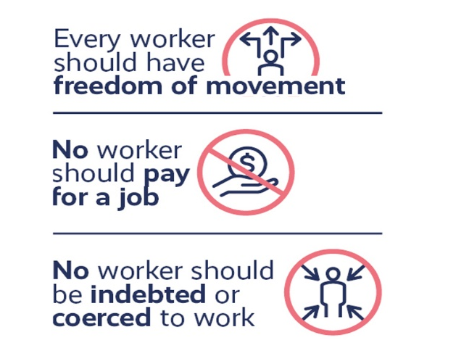
- To not be discriminated against for exercising your health and safety rights. Your employer may not fire you, threaten you, harass you, or treat you differently for exercising your health and safety rights.
- To refuse work that puts you in immediate danger of serious harm. Before you refuse unsafe work, request that your employer eliminate the hazard and make it clear that you will accept an alternate assignment. The OSHA regulation only protects you if the danger can be proven to exist; if you refuse to work because you believe a condition is hazardous, but are proved wrong, OSHA does not protect you.
- To information on hazards in your workplace; chemicals used in your workplace; tests your employer has done to measure chemical, noise and radiation levels; and what to do if you or other employees are involved in an incident or are exposed to other toxic substances.
- To information from your employer about OSHA standards, worker injuries and illnesses, job hazards and workers' rights.
- To training from your employer:
  - on chemicals you are exposed to during your work and information on how to protect yourself from harm.
  - on other health and safety hazards and standards that your employer must follow.

As a worker, it is your responsibility to:
- Read the workplace safety and health poster at the jobsite.
- Comply with all applicable OSHA and safety standards.
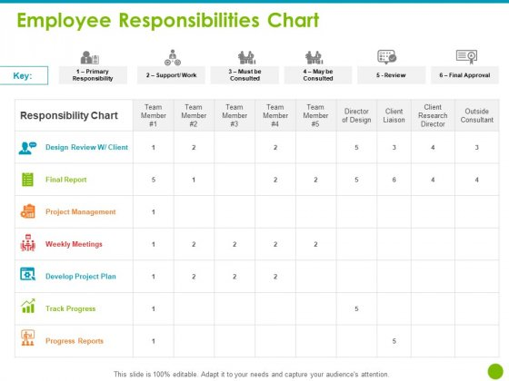
- Follow all lawful employer safety and health rules and regulations, and wear or use required protective equipment while working.
- Report hazardous conditions to the employer.
- Report any job-related injury or illness to the employer, and seek treatment promptly.

Employer Responsibilities
- Provide a workplace free from serious hazards
- Comply with OSHA standards
- Make sure employees have and use safe tools and equipment. Properly maintain this equipment.
- Use color codes, posters, labels or signs to warn employees of potential hazards.
- Establish or update operating procedures and communicate them so that employees follow safety and health requirements.
- Keep records of work-related injuries and illnesses and post these records.
- Provide access to employee medical records and exposure records to employees or their authorized representatives.
- Not discriminate against employees who exercise their safety and health rights.

STAKEHOLDER CONSULTATION TO OBTAIN POINT OF VIEW ON LEGAL OBLIGATIONS
Entrusted with a leadership role, stakeholders are responsible for overseeing a department or group of employees within a specific organization or company. Managers are utilized in every sector, and the business model relies on their leadership and ability to operationalize the management structure. Working as a manager is an accomplishment because it reveals a professional’s ability to successfully lead, oversee multiple business operations, manage stress, and effectively communicate with coworkers.

To be successful on the job, managers tend to adopt the following management approaches:
- Contingency Approach: The Contingency Approach is an approach based on the idea that management techniques should change depending on the particular situation. In other words, managers adapt appropriately to various situations and alter their management styles according to these situations.
- Behavioral Approach: To facilitate a positive work environment, managers approach their jobs with an awareness of employees’ needs for workplace satisfaction. Contemporary Approach: This approach argues that effective managers maintain a strong staff and equip that staff with the proper tools to make the workplace more efficient and satisfying.

- Across every sector, managers contribute to businesses in significant ways, which are reflected in company profits, organization, and overall workplace morale.

IMPLICATIONS OF COMPLIANCE AND NON-COMPLIANCE

Compliance
Legal compliance is the process by which a company adheres to the complex rules, policies and processes that regulate business practice in a particular jurisdiction.
Compliance involves not only knowing and understanding the legislation that applies to the organization, but also being able to demonstrate that the business and its entities are in compliance at all times.

The Basic Conditions of Employment Act
The Basic Conditions of Employment Act (BCEA) provides for minimum terms on which employees must be employed in relation to such things as annual leave, sick leave, overtime and daily and weekly maximum working hours.

Certain provisions of the BCEA are regarded to be terms of an employment contract whether or not the employer and employee intended differently. The BCEA prescribes minimum terms and conditions of employment such as maximum ordinary hours of work and overtime, minimum payment for overtime worked including work performed on Sundays and public holidays as well as minimum meal intervals, rest periods and leave provisions, including minimum annual leave and maternity leave.


The BCEA encourages transparency in the workplace by obliging employers to furnish employees with particulars of employment as well as information in respect of their remuneration.

In recognizing that the unique nature of particular industries may necessitate variations to the prescribed terms and conditions of employment, the BCEA makes provision for employers to vary the prescribed conditions of employment, either through collective agreements concluded with trade unions, individual agreements concluded with employees, or formal variations granted by the Minister of Labour.

The purpose of the BCEA can be summarized as follows:

- Gives effect to the right to fair Labour practices referred to in section 23(1) of the Constitution by establishing and making provision for the regulation of basic conditions of employment
- Complies with the obligations of the Republic as a member state of the International Labour Organization
- Provides for matters connected to Labour practices

Employee issues covered by the Act:
- Regulation of working time
- Leave
- Particulars of employment and remuneration
- Termination of employment
- Prohibition of employment of children and enforced Labour
- Protection of employees against discrimination

The Basic Conditions of Employment Act requires that employers give workers certain details of their employment in writing:

Employer and Worker Details
- Employer’s full name
- Employer’s address
- Worker’s name

Worker’s occupation or a brief description of the work
- Employment Details
- Place/s of work
- Date of employment
- Working hours and days of work

Payment Details
- Salary or wage, or the rate and method of calculating wages
- Rate for overtime
- Any other cash payments
- Any payments in kind and their value
- Frequency of payment
- Any deductions

Leave Details
- Any leave to which the worker is entitled

Notice/Contract Period
- Period of notice required for termination; or
- Period of contract
- List of any other documents that form part of the contract and details of where the worker can get copies
- Description of any council or sectoral determination which covers the employer’s business

Note:
The section of the Act that regulates working hours does not apply to:
- workers in senior management
- sales staff who travel and regulate their own working hours
- workers who work fewer than 24 hours in a month
- workers who earn more than R115 572 per year

Non-Compliance

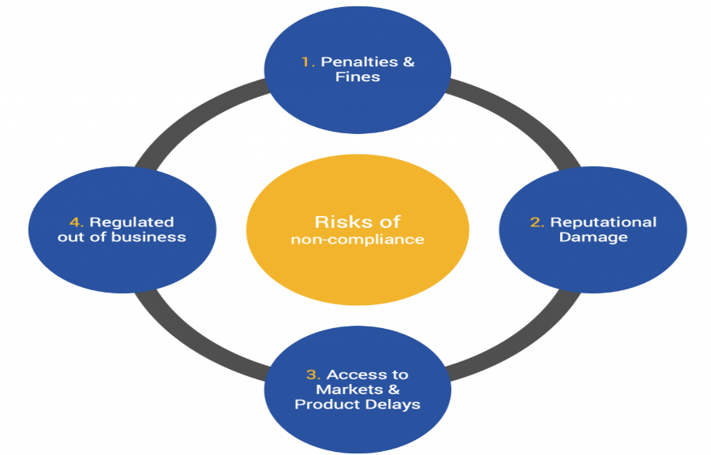
Non-Compliance refers to failure or refusal to comply, as with a law, regulation, or term of a contract. Recently a major airline operating in South Africa was reported to have been fined R900 000 for failing to comply with the Employment Equity Act (EEA). This penalty highlights the seriousness with which the Department of Labour (DOL) takes non-compliance with the provisions of the act and shows that they will not hesitate to bring the maximum penalty against defaulters.
If you are a designated employer, you have only a few weeks to submit your Employment Equity Report. Designated employers are those that either have more than 50 employees or that have fewer than 50 employees, but have an annual sales turnover that exceeds the threshold for their sector.
Employers are warned that, while submitting their EE Report in time is crucial, this is not enough to ensure full compliance with the requirements of the legislation. Employers are also legally bound to ensure that the report's contents are true and correct and that they can show that they have made sufficient progress with affirmative action in the staffing of their organizations as required by the EEA.
It is clear that prosecutions in the Labour Court and potentially bankrupting fines, can result if employers fail to comply.
This means that designated employers will have to:
- Shift from merely putting together "impressive looking" reports for the DOL;
- Do a detailed employment equity (EE) analysis;
- Set affirmative action targets that are achievable on the one hand, but substantial enough on the other hand to satisfy the director-general of Labour;
- Prepare and implement a detailed EE plan. This is a comprehensive strategy for recruiting, "accommodating" and developing members of designated groups.
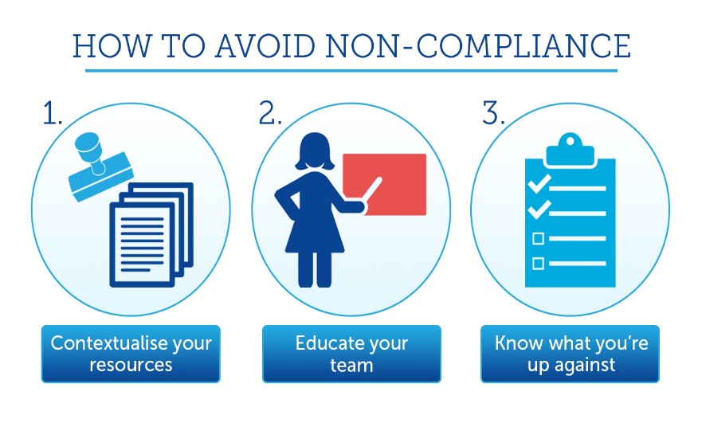
That is, each employer must devise an action plan aimed at ensuring that it has the right proportion of designated people - black, coloured, Indian, female and disabled people, working in all departments and at all levels of the organization, including the very top levels of management. For example, if you have 50 members on your board of directors, then you must aim to have approximately 35 black, five coloured, four Indian and five white directors.
Of these, 25 should be female and two should be disabled:
- Ensure that these plans are implemented effectively and in tune with the EEA's procedural requirements;
- Consult with a full cross-section of their workforce and representative trade unions on the devising and implementation of the above-mentioned analysis, report, plan and target;
- Make available to employees all the relevant documents - employment equity report and employment equity plan;
- Make special arrangements to ensure that black, colored, Indian, female and disabled employees are able to remain with the organization, cope with their duties and work environment, that they fit into the organization and to advance in the organization; and
- Eliminate barriers to employment of members of designated groups.

While none of these requirements are impossible, they will be very much more difficult to achieve with the DOL inspectors breaking down your door. It is important to bear in mind that, once you have set up your EE system, based on your own level of resources and circumstances, the task of EE compliance becomes very much easier. While potential investors are being deterred by South Africa's Labour law requirements, the director general is charged with implementing the law with regard to affirmative action. He therefore has no option but to police employers that do not comply and to prosecute those that do not heed his instructions to implement affirmative action meaningfully. Unfortunately, the EEA does not sufficiently take into account the fact that the number of jobs available in South Africa is not increasing.
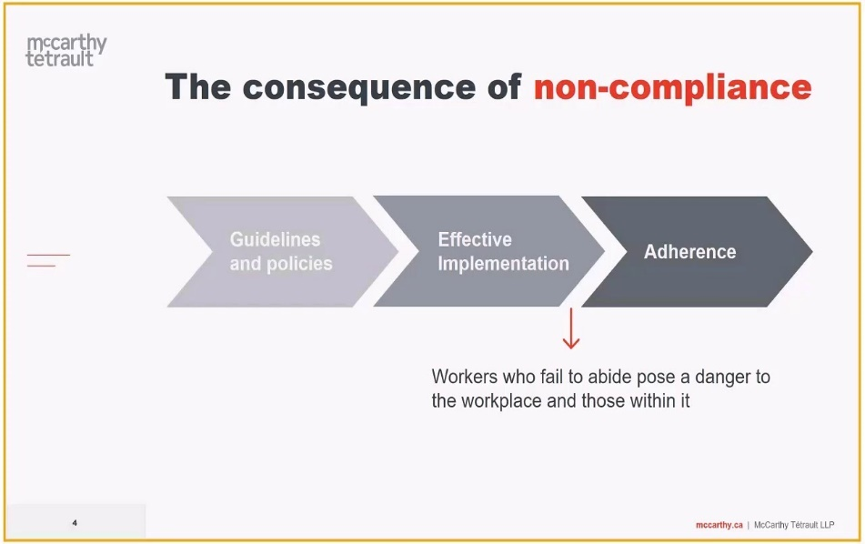
This makes it extremely difficult for you to increase your numbers of employees from designated groups even if you want to. However, as long as you can prove that you are doing everything possible to normalize the demographics of your organization and that you have been completing the compulsory analyses, reports and plans, the DOL is unlikely to take action against you.
You have everything to gain and nothing to lose by using the help of a Labour law expert to devise your EE analysis, report, plan, target and consultation system. Otherwise, at the Labour Court, you will not only be forced to implement EE and to pay crippling fines; you may also be faced with having to meet imposed EE targets.

- ANALYSE THE COMPLIANCE TO LEGAL AND OTHER REQUIREMENTS THAT REGULATE THE UNIT

COMPLIANCE TO LEGAL AND OTHER REQUIREMENTS

    - Introduction to Legal and other requirements

They say that the smartest people among us are those who adopt a positive attitude towards life-long learning. In other words, the smartest people are those who realize they will always have a lot to learn, and who spend their entire lives accumulating knowledge to improve their skills development process.
Learning is, then, a life-long process; there is never a point at which you can stop and say that you have learnt everything, or know enough (if you want to be one of the smartest people in the room, or a sought-after professional, that is).

To be more, we need to become more.


Each industry, and each company within that industry, will have a different approach to skills development. Some companies will have in-house training opportunities and grants for further learning for exceptional employees. Others will have minimum standards – i.e. a set of basic skills the company requires new hires to possess before they will put in the time and money required to develop those skills further.
Some businesses will require employees to undergo a series of tests and short courses throughout their tenure to ensure that their employees continue to develop the necessary skills to remain at the forefront of knowledge and the cutting edge of their field. Whatever a company’s approach to skills development, you can bet your bottom dollar that skills development is a billion-dollar industry vital to a company’s long-term growth and ultimate success.
While many large corporates have been busy implementing skills development programmers, SMMEs still lag far behind, which means they’re losing out on two fronts. Think of it this way. You have to pay the levy anyway, so you might as well implement a skills development programme.
You will be able to claim back a large portion of that money, while also improving the skills of your employees – something that can only benefit your business in the long run. And depending on the size of your company’s payroll, the amount you can claim back can add up to quite a bit of money. You can recover:
- 15% of the levy your company pays when you appoint and register a skills development facilitator
- 10% of the levy when you prepare, submit and get approval for a workplace skills plan for the appropriate SETA
- 20% of the levy when you prepare an annual training report based on your approved workplace skills plan

In addition, each SETA makes grants available for specific sector skills initiatives, depending on certain criteria, and these add up to an additional 5% of the total levy paid. Many small businesses can’t be bothered, or don’t have the time, to deal with the paperwork and administration involved in claiming back what is sometimes a small amount of money from SETAs. But the benefits do not just lie in putting money back in your business’s pocket. There are enormous advantages to be derived from upskilling your employees and any small business that is truly invested in growth should have some sort of training and development programme, regardless of whether or not they can claim money back from SETAs.

But to make the system work for your business, you need to understand the basics. For the South African economy to grow and flourish there is an urgent need to address the severe skills shortage that exists in the country. This cannot be achieved without the help of business which is why government implemented the Skills Development Act to provide a framework for skills development in the workplace.


Government set up SETAs to identify skills development needs in each sector; facilitate the development and implementation of a strategic sector skills development plan; approve learnerships; meet the agreed standards for education and training within an agreed national framework to control quality; and to pay out grants. In total, there are 22 SETAs. They receive 80% of levies collected, while the remaining 20% is distributed to the National Skills Development Fund for projects that fall outside any of the established SETAs.

To be eligible to claim back from a SETA you first have to appoint a skills development facilitator. This person can be full-time, part-time or on contract, but they need to be registered with your business sector’s SETA. Their role is to assist you with the second part of the process which is the development of a workplace skills plan and the submission of this to the relevant SETA. They should also be able to advise you on how to implement the plan, assist you in putting together the necessary annual training report (step three), advise you on the quality assurance requirements as set by the relevant SETA and serve as a contact person between your business and your SETA.

In addition to the grants that you can claim by implementing these steps, there are a number of discretionary grants that the SETAs may also make. These are for learnerships, skills programmes, apprentices and sector priorities. By implementing these in the correct way, you can claim back additional funds.

A learnership is an alternative form of training that places the emphasis on practical experience and culminates in the learner receiving an NQF (National Qualifications Framework) qualification. It can include classroom-based learning at a training Centre or college and on-the-job training in a workplace and it has to be approved by the relevant SETA. As an employer, you can seek a grant from a SETA to support the implementation of a learnership. The first type of grant is to offset the costs of implementing a learnership, (such as off-the-job education and training provider fees), while the second subsidies the learner’s allowance if the learner was unemployed immediately before starting the learnership.

The following steps are required to set up a learnership:
- Decide which skills your company needs and choose any learnership offered by any Sector Education Training Authority (SETA) that meets these needs.
- You can apply for a grant from your SETA once you have signed a learnership agreement. However, it is important that you contact your SETA before you sign the learnership agreement to make sure that the SETA has enough money available.
- Find someone in your organization to guide the learners and help them with problems they might face.
- Get someone to assist the learners with the academic part of the learnership by choosing a training provider. The training provider must be accredited by a SETA.
- You can choose learners from among your workers or you may choose unemployed people for the learnership. Contact the nearest labour centre for a list of available unemployed candidates. You do not have to provide employment to these unemployed learners after the learnerships are complete.
- You, the training providers and the learners must sign a learnership agreement.
- You must sign a contract with unemployed learners that complies with the Sectoral Determination for Learnerships. It is not necessary to sign new contracts with workers already working for you.

It is important that you register your learnership agreement with the SETA. If you do not, you will not be able to claim the tax break from SARS. Contact SARS for more details on how to claim the tax break. Once all the above steps have been finalized, you can implement the learnership.

3.1.2 Code of Conduct in a Workplace

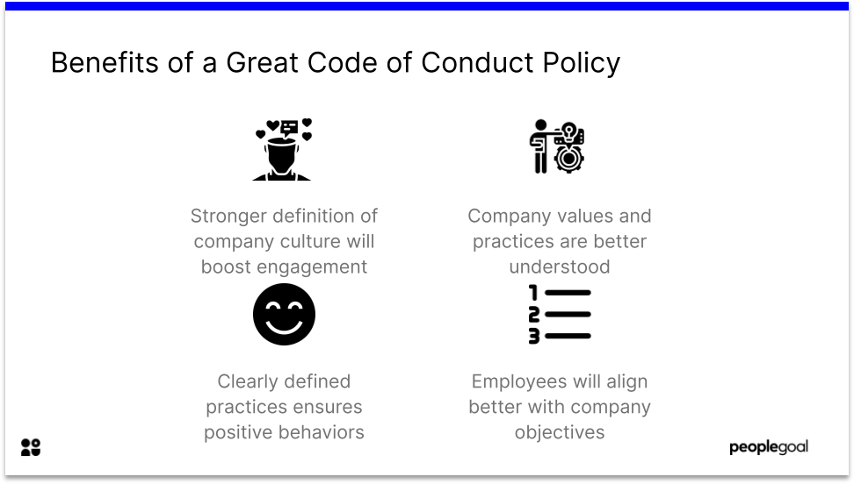
An organizational workplace code of conduct establishes acceptable standards of behavior for all employees. Some departments also have codes specific to employees working in areas such as human resources, sales and service. The code of conduct is intended to serve as an internal communication tool as well as a device to protect the company in cases where it must terminate an employee for cause.
Common items covered in a workplace code of conduct include employee dress codes, attendance policies, health and safety standards, use of company property and appropriate workplace behaviors. The code starts with an introduction and statement of purpose, outlines each category and conveys consequences of poor conduct. The code of conduct is a formal document given to new hires along with the company policy manual. New employees normally sign a document indicating they have received and read the code of conduct.

Employee Benefits
Communication of expectations helps establish clear boundaries. Some employees would rather know specifically what is and is not acceptable at work and the consequences of poor decisions. With a dress code, for instance, employees benefit when examples are provided of professional or business casual dress. When a company simply dictates a business casual dress code, employees must come up with their own interpretation of the standard. In sales, there are issues in relationships with customers related to giving and accepting gifts, confidentiality, conflicts of interest and disclosure of information, and code of conduct specific to sales staff should give employees key guidelines in each area to avoid uncertainty and indecision.

Human resources professionals are leery about having to protect the company against wrongful termination claims and possible allegations of discrimination. If an employee indicates he was discriminated against in a reprimand, the company can use its code of conduct to cite specific ethical or behavioral standards the employee violated. This makes documenting any warnings or prior incidents important, especially when the company terminates based on a consistent pattern of behavior that violates the code. For instance, when an employee is fired because of regular absences and tardiness, the company can refer to its attendance code and provide documentation of the employee's attendance records.

    - Disadvantages of a code of conduct in the workplace

- Inequality

Codes of conduct are often drafted, in part, to ensure that all members of an organization are treated equally. However, often those in upper-level management and creative positions are given a "bye" on certain codes, like those restricting how the worker talks about the company or to what degree employees are allowed to have personal relationships outside of work. If companies are going to have codes of conduct, they should reconsider any code that cannot be applied equally.
- Unenforceability
Some codes of conduct, perhaps because of employee misconduct in the past, take a micromanagement approach, dictating detailed minutia like the kinds of material that can be worn in the office or the exact length of personal phone calls. According to Leadership Skills for Life, it is important for codes of conduct to be detailed because some questions, like whether or not taking a company pen home is ethical, will render many answers. However, such codes can be cumbersome, contradictory and ultimately ineffective when people, including supervisors who cannot enforce the codes and still have a productive workplace, abandon them in favour of "common sense." On the other hand, a company in which the value of honesty is embedded and appreciated can result in a culture where no one would consider taking a pen.

- Unethical Corporate Behavior
In some cases, codes of conduct may facilitate unethical corporate behavior. Codes of conduct that limit employees' ability to speak out against the corporation can keep them quiet for fear of job loss or legal retribution even if the company is engaging in an unethical practice. Further, codes of conduct can be used to set ethical-looking rules that managers are instructed not to follow so if any misconduct occurs it is the individual employee, not the corporation that will be blamed.

- Lack of Stability
Although many codes of conduct are developed out of corporate values, mission statements and even past incidents of company impropriety, there is rarely anything holding corporations to their own codes of conduct. In other words, they are not stable, and owners or boards of directors can revise them to include the company's current needs and desires -- be they ethical or not -- at any time.
- Time

As with other strategic plans or documents, it takes time to create a code of conduct. While company leaders could rush through and put pen to paper, a thoughtful code that provides long-term ethical stability takes longer. If different departments are consulted or outside consultants brought in to help with the process, the expenses only multiply.

- Enforcement obligations
One of the biggest challenges of a code of conduct is the need to follow-through on enforcement of its tenets. If employees pick up on the fact that nothing is ever said or done about violations, the code is worth little more than the paper it is printed on. Not only do you need to display enforcement that aligns with stated policies, but employees should also believe that leaders consistently apply the code to all workers. Inconsistent application can lead to envy, tension and poor morale.

    - Advantages of a code of conduct in the workplace

- Workplace Culture
A policy of ethical compliance helps to create a workplace culture where all employees are treated with respect. Employees are given equal access to advancement opportunities and the workplace becomes a positive and nurturing environment. A strong ethical standard in the workplace helps to create strong working relationships between the staff and management. It reduces employee turnover, improves morale and has a positive effect on productivity.

- Company Reputation
Businesses work hard to gain competitive advantages. Gaining advantages from a positive reputation in the marketplace can be enough to secure a sizable market share from your larger competitors. Proudly displaying your code of ethics on your website or in press releases, while taking care to ensure that your actions are always in line with your words, can garner a positive image among consumers and job-seekers, creating a loyal customer base and helping to develop your brand image.

- Strategic Decision-Making
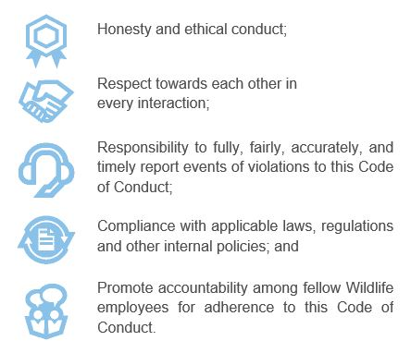
Business owners make decisions at the executive level of their company. A code of ethics in a business can provide a foundation on which to base all decisions that affect internal and external stakeholders,

such as employees or residents in the local community. Ethical dilemmas faced by small business owners most often do not have the same scope as issues faced by corporate executives, such as laying off thousands of workers or introducing tons of pollutants into the environment. However, having a solid code of ethics in place from the beginning can help to guide you as your company eventually grows to a corporate size.

- Responsibility
When people take responsibility for their actions, everyone benefits. Responsibility is accountability and honesty, and holding yourself accountable promotes these good character traits in others who see them in you. This helps to create a cohesive and productive work force, which has several of its own benefits, not the least of which is longer employee retention. Employees are more likely to continue to working for a company that follows and promotes rules that protect and benefit everyone equally.

- Marketing
A code serves as a public statement of what the company stands for and its commitment to high standards and right conduct.

THE REQUIREMENTS OF THE LABOUR RELATIONS ACT AND CODE OF GOOD PRACTICE REGARDING DISMISSAL

Code of Good Practice – Dismissal

Fair reasons for dismissal

- A dismissal is unfair if it is not affected for a fair reason and in accordance with a fair procedure, even if it complies with any notice period in a contract of employment or in legislation governing employment. Whether or not a dismissal is for a fair reason is determined by the facts of the case, and the appropriateness of dismissal as a penalty. Whether or not the procedure is fair is determined by referring to the guidelines set out below.
- This Act recognizes three grounds on which a termination of employment might be legitimate. These are: the conduct of the employee, the capacity of the employee, and the operational requirements of the employer's business.
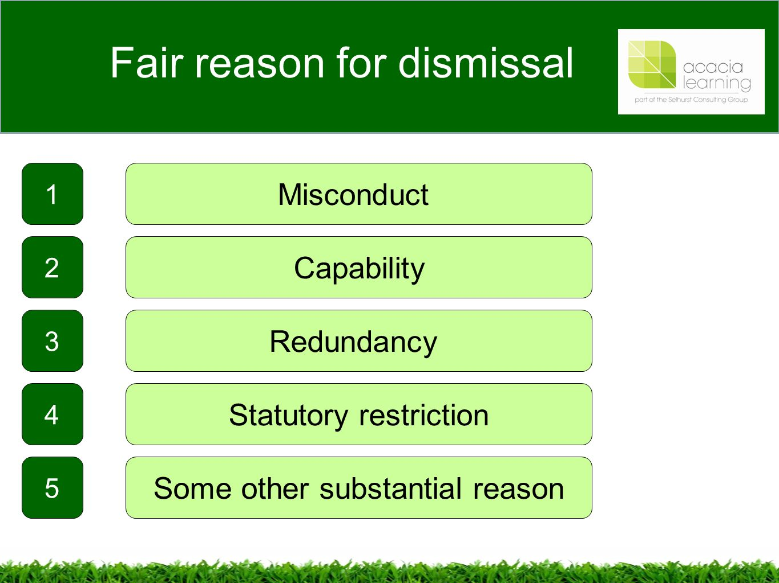
- This Act provides that a dismissal is automatically unfair if the reason for the dismissal is one that amounts to an infringement of the fundamental rights of employees and trade unions, or if the reason is one of those listed in section 187. The reasons include participation in a lawful strike, intended or actual pregnancy and acts of discrimination.
- In cases where the dismissal is not automatically unfair, the employer must show that the reason for dismissal is a reason related to the employee's conduct or capacity, or is based on the operational requirements of the business. If the employer fails to do that, or fails to prove that the dismissal was affected in accordance with a fair procedure, the dismissal is unfair.
Disciplinary procedures prior to dismissal

- All employers should adopt disciplinary rules that establish the standard of conduct required of their employees. The form and content of disciplinary rules will obviously vary according to the size and nature of the employer's business.
- In general, a larger business will require a more formal approach to discipline. An employer's rules must create certainty and consistency in the application of discipline. This requires that the standards of conduct are clear and made available to employees in a manner that is easily understood. Some rules or standards may be so well established and known that it is not necessary to communicate them. The courts have endorsed the concept of corrective or progressive discipline.
- This approach regards the purpose of discipline as a means for employees to know and understand what standards are required of them. Efforts should be made to correct employees' behavior through a system of graduated disciplinary measures such as counselling and warnings. Formal procedures do not have to be invoked every time a rule is broken or a standard is not met. Informal advice and correction is the best and most effective way for an employer to deal with minor violations of work discipline. Repeated misconduct will warrant warnings, which themselves may be graded according to degrees of severity. More serious infringements or repeated misconduct may call for a final warning, or other action short of dismissal. Dismissal should be reserved for cases of serious misconduct or repeated offences.

Dismissals for misconduct
Generally, it is not appropriate to dismiss an employee for a first offence, except if the misconduct is serious and of such gravity that it makes a continued employment relationship intolerable. Examples of serious misconduct, subject to the rule that each case should be judged on its merits, are gross dishonesty or willful damage to the property of the employer, willful endangering of the safety of others, physical assault on the employer, a fellow employee, client or customer and gross insubordination.


Whatever the merits of the case for dismissal might be, a dismissal will not be fair if it does not meet the requirements of section 188. When deciding whether or not to impose the penalty of dismissal, the employer should in addition to the gravity of the misconduct consider factors such as the employee's circumstances (including length of service, previous disciplinary record and personal circumstances), the nature of the job and the circumstances of the infringement itself.

The employer should apply the penalty of dismissal consistently with the way in which it has been applied to the same and other employees in the past, and consistently as between two or more employees who participate in the misconduct under consideration.

Fair procedure

- Normally, the employer should conduct an investigation to determine whether there are grounds for dismissal. This does not need to be a formal enquiry. The employer should notify the employee of the allegations using a form and language that the employee can reasonably understand. The employee should be allowed the opportunity to state a case in response to the allegations. The employee should be entitled to a reasonable time to prepare the response and to the assistance of a trade union representative or fellow employee. After the enquiry, the employer should communicate the decision taken, and preferably furnish the employee with written notification of that decision.
- Discipline against a trade union representative or an employee who is an office-bearer or official of a trade union should not be instituted without first informing and consulting the trade union.
- If the employee is dismissed, the employee should be given the reason for dismissal and reminded of any rights to refer the matter to a council with jurisdiction or to the Commission or to any dispute resolution procedures established in terms of a collective agreement.
- In exceptional circumstances, if the employer cannot reasonably be expected to comply with these guidelines, the employer may dispense with pre-dismissal procedures.

Disciplinary records
Employers should keep records for each employee specifying the nature of any disciplinary transgressions, the actions taken by the employer and the reasons for the actions.

Dismissals and industrial action

- Participation in a strike that does not comply with the provisions of Chapter IV is misconduct. However, like any other act of misconduct, it does not always deserve dismissal. The substantive fairness of dismissal in these circumstances must be determined in the light of the facts of the case, including:
(a) the seriousness of the contravention of this Act;
(b) attempts made to comply with this Act; and
(c) whether or not the strike was in response to unjustified conduct by the employer.
- Prior to dismissal the employer should, at the earliest opportunity, contact a trade union official to discuss the course of action it intends to adopt. The employer should issue an ultimatum in clear and unambiguous terms that should state what is required of the employees and what sanction will be imposed if they do not comply with the ultimatum. The employees should be allowed sufficient
time to reflect on the ultimatum and respond to it, either by complying with it or rejecting it. If the employer cannot reasonably be expected to extend these steps to the employees in question, the employer may dispense with them.

Guidelines in cases of Dismissal for Misconduct

Any person who is determining whether a dismissal for misconduct is unfair should consider:

(a) whether or not the employee contravened a rule or standard regulating conduct in, or of relevance to, the workplace; and
(b) if a rule or standard was contravened, whether or not-
(i) the rule was a valid or reasonable rule or standard;
(ii) the employee was aware, or could reasonably be expected to have been aware, of the rule or standard;
(iii) the rule or standard has been consistently applied by the employer; and
(iv) dismissal was an appropriate sanction for the contravention of the rule or standard.

Incapacity: Poor work performance

- A newly hired employee may be placed on probation for a period that is reasonable given the circumstances of the job. The period should be determined by the nature of the job, and the time it takes to determine the employee's suitability for continued employment. When appropriate, an employer should give an employee whatever evaluation, instruction, training, guidance or counselling the employee requires to render satisfactory service. Dismissal during the probationary period should be preceded by an opportunity for the employee to state a case in response and to be assisted by a trade union representative or fellow employee.
- After probation, an employee should not be dismissed for unsatisfactory performance unless the employer has:
- given the employee appropriate evaluation, instruction, training, guidance or counselling; and
- after a reasonable period of time for improvement, the employee continues to perform unsatisfactorily.

- The procedure leading to dismissal should include an investigation to establish the reasons for the unsatisfactory performance and the employer should consider other ways, short of dismissal, to remedy the matter.
- In the process, the employee should have the right to be heard and to be assisted by a trade union representative or a fellow employee.

Guidelines in cases of Dismissal for Poor Work Performance
Any person determining whether a dismissal for poor work performance is unfair should consider
(a) whether or not the employee failed to meet a performance standard; and
(b) if the employee did not meet a required performance standard whether or not-
(i) the employee was aware, or could reasonably be expected to have been aware, of the required performance standard;
(ii) the employee was given a fair opportunity to meet the required performance standard; and
(iii) dismissal was an appropriate sanction for not meeting the required performance standard.

Incapacity: ill health or injury
    - Incapacity on the grounds of ill health or injury may be temporary or permanent. If an employee is temporarily unable to work in these circumstances, the employer should investigate the extent of the incapacity or the injury. If the employee is likely to be absent for a time that is unreasonably long in the circumstances, the employer should investigate all the possible alternatives short of dismissal.
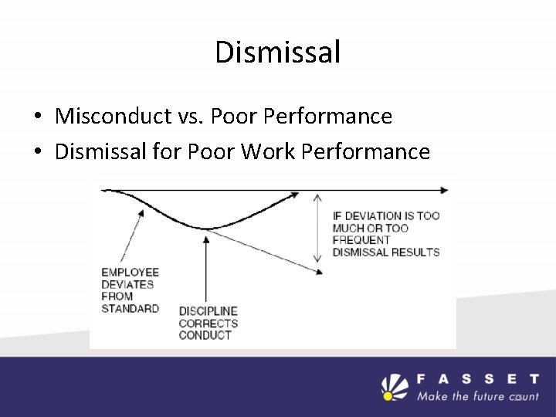
When alternatives are considered, relevant factors might include the nature of the job, the period of absence, the seriousness of the illness or injury and the possibility of securing a temporary replacement for the ill or injured employee. In cases of permanent incapacity, the employer should ascertain the possibility of securing alternative employment, or adapting the duties or work circumstances of the employee to accommodate the employee's disability.
    - In the process of the investigation referred to in subsection (1) the employee I should be allowed the opportunity to state a case in response and to be assisted by a trade union representative or fellow employee.
    - The degree of incapacity is relevant to the fairness of any dismissal. The cause of the incapacity may also be relevant. In the case of certain kinds of incapacity, for example alcoholism or drug abuse, counselling and rehabilitation may be appropriate steps for an employer to consider.
    - Particular consideration should be given to employees who are injured at work or who are incapacitated by work-related illness. The courts have indicated that the duty on the employer to accommodate the incapacity of the employee is more onerous in these circumstances.

THE BASIC CONDITIONS OF EMPLOYMENT ACT

The Basic Conditions of Employment Act (BCEA) provides for minimum terms on which employees must be employed in relation to such things as annual leave, sick leave, overtime and daily and weekly maximum working hours.

Certain provisions of the BCEA are regarded to be terms of an employment contract whether or not the employer and employee intended differently. The BCEA prescribes minimum terms and conditions of employment such as maximum ordinary hours of work and overtime, minimum payment for overtime worked including work performed on Sundays and public holidays as well as minimum meal intervals, rest periods and leave provisions, including minimum annual leave and maternity leave.

The BCEA encourages transparency in the workplace by obliging employers to furnish employees with particulars of employment as well as information in respect of their remuneration. The following is a summary of the provisions of the most important sections of the Basic Conditions of Employment Act, 1997, as amended.

Application of the Act: Section 3
The Act applies to all employees and employers except members of the National Defence Force, National Intelligence Agency, South African Secret Service and unpaid volunteers working for an organisation with a charitable purpose. The basic conditions of employment contained in the Act form part of the contract of employment of employees covered by the Act. Some, but not all, basic conditions
of employment may be varied by individual or collective agreements in accordance with the provisions of the Act. (see paragraph 7 below).

Regulation of Working Time: Chapter Two
2.1 Application
This chapter does not apply to senior managerial employees, employees engaged as sales staff who travel and employees who work less than 24 hours a month.
2.2 Ordinary hours of work: Section 9

No employer shall require or permit an employee to work more than:
- 45 hours in any week;
- nine hours in any day if an employee works for five days or less in a week; or
- eight hours in any day if an employee works on more than five days in a week.

2.3 Overtime: Section 10
2.3.1 An employer may not require or permit an employee:
- to work overtime except by an agreement;
- to work more than ten hours’ overtime a week.
2.3.2 An agreement may not require or permit an employee to work more than 12 hours on any day.
2.3.3 A collective agreement may increase overtime to fifteen hours per week for up to two months in any period of 12 months.
2.3.4 Overtime must be paid at 1.5 times the employee’s normal wage or an employee may agree to receive paid time off.

2.4 Compressed working week: Section 11
2.4.1 An employee may agree in writing to work up to 12 hours in a day without receiving overtime pay.
2.4.2 This agreement may not require or permit an employee to work:
- more than 45 ordinary hours in any week;
- more than ten hours’ overtime in any week; or
- more than five days in any week.

2.5 Averaging of hours of work: Section 12
2.5.1 A collective agreement may permit the hours of work to be averaged over a period of up to four months.
2.5.2 An employee who is bound by such a collective agreement may not work more than:
- an average of 45 ordinary hours in a week over the agreed period;
- an average of five hours’ overtime in a week over the agreed period.

2.6 Meal intervals: Section 14
    - An employee must have a meal interval of 60 minutes after five hours work.

    - An employee who occasionally works on a Sunday must receive double pay.

    - An employee who ordinarily works on a Sunday must be paid at 1.5 times the normal wage.

2.8.3 Paid time off in return for working on a Sunday may be agreed upon.

2.9 Night work: Section 17

    - Employees who work at night between 18h00 and 06h00 must be compensated by payment of an allowance or by a reduction of working hours and transport must be available.

    - Employees who work regularly after 23:00 and before 06:00 the next day must be informed⎯
- of any health and safety hazards; and
- the right to undergo a medical examination.

2.10 Public holidays: Section 18

2.10.1 Employees must be paid their ordinary pay for any public holiday that falls on a working day.

    - Work on a public holiday is by agreement and paid at double the rate.

2.10.3 A public holiday may be exchanged with another day by agreement.

2.6.2 A written agreement may:
- reduce the meal interval to 30 minutes;
- dispense with the meal interval for employees who work fewer than six hours on a day.

2.7 Daily and weekly rest period: Section 15
An employee must have a daily rest period of 12 consecutive hours and a weekly rest period of 36 consecutive hours, which, unless otherwise agreed, must include Sunday.

  - Pay for work on Sundays: Section 16
    - An employee who occasionally works on a Sunday must receive double pay.
    - An employee who ordinarily works on a Sunday must be paid at 1.5 times the normal wage.
2.8.3 Paid time off in return for working on a Sunday may be agreed upon.

  - Night work: Section 17
    - Employees who work at night between 18h00 and 06h00 must be compensated by payment of an allowance or by a reduction of working hours and transport must be available.
    - Employees who work regularly after 23:00 and before 06:00 the next day must be informed⎯
- of any health and safety hazards; and
- the right to undergo a medical examination.
  - Public holidays: Section 18
    - Employees must be paid their ordinary pay for any public holiday that falls on a working day.
    - Work on a public holiday is by agreement and paid at double the rate.
    - A public holiday may be exchanged with another day by agreement.

3. LEAVE: CHAPTER THREE
  - Application
The chapter on leave does not apply to an employee who works less than 24 hours a month for an employer and to leave granted in excess of the leave entitlement under this chapter.

3.2 Annual leave: Sections 20 & 21
3.2.1 Employees are entitled to 21 consecutive days’ annual leave or by agreement, one day for every 17 days worked or one hour for every 17 hours worked.
3.2.2 Leave must be granted not later than six months after the end of the annual leave cycle.
3.2.3 An employer must not pay an employee instead of granting leave except on termination of employment.

3.3 Sick leave: Sections 22 – 24
3.3.1 An employee is entitled to six weeks’ paid sick leave in a period of 36 months.
3.3.2 During the first six months an employee is entitled to one day’s paid sick leave for every 26 days worked.

    - An employer may require a medical certificate before paying an employee who is absent for more than two consecutive days or who is frequently absent.

3.4 Maternity leave: Sections 25 & 26

    - A pregnant employee is entitled to four consecutive months’ maternity leave.

3.4.2 A pregnant employee or employee nursing her child is not allowed to perform work that is hazardous to her or her child.

3.5 Family responsibility leave: Section 27

3.5.1 Full time employees are entitled to three days paid family responsibility leave per year, on request, when the employee’s child is born or sick, or in the event of the death of the employee’s spouse or life partner, or the employee’s parent, adoptive parent, grandparent, child, adopted child, grandchild or sibling.

3.5.2 An employer may require reasonable proof.

4. PARTICULARS OF EMPLOYMENT AND REMUNERATION: CHAPTER FOUR

4.1 Application

This chapter does not apply to an employee who works less than 24 hours a month for an employer.

4.2 Written particulars of employment: Section 29
4.2.1 An employer must supply an employee when the employee commences employment, with the following particulars in writing:
- full name and address of the employer;
- name and occupation of the employee, or a brief description of the work ;
- various places of work;
- date of employment;
- ordinary hours of work and days of work;
- wage or the rate and method of calculating;
- rate for overtime work;
- any other cash payments;
- any payment in kind and the value thereof;
- frequency of remuneration;
- Any deductions;
- leave entitlement;
- period of notice or period of contract;
- description of any council or sectoral determination which covers the employer’s business;
- period of employment with a previous employer that counts towards the period of employment;
- list of any other documents that form part of the contract, indicating a place where a copy of each may be obtained.
4.2.2 Particulars must be revised if the terms of employment change.

4.3 Informing employees of their rights: Section 30
A statement of employees’ rights must be displayed at the workplace in official languages used at the workplace.

4.4 Keeping of records: Section 31
Every employer must keep a record containing the following information:
- employee’s name and occupation;
- time worked;
- remuneration paid;
- date of birth if under 18 years of age; and
- any other prescribed information.

4.5 Information about remuneration: Section 33

The following information must be given in writing when the employee is paid:
- employer’s name and address;
- employee’s name and occupation;
- period of payment;
the period of payment;
- number of hours worked on a Sunday or public holiday during that period; and
- if an agreement to average working time has been concluded, the total number of ordinary and overtime hours worked in the period of averaging.
4.6 Deductions and other acts concerning remuneration: Sections 34 and 34A

4.6.1 An employer may not deduct money from an employee’s remuneration unless –
- The employee agrees in writing to the deduction of a specific debt;
- The deduction is made in terms of a collective agreement, law, court order or arbitration award

4.6.2 A deduction in respect of damage or loss caused by the employee may only be made with agreement and after the employer has followed a fair procedure

4.6.3 Employers must pay deductions and employer contributions to benefit funds to the fund within seven days.
4.7 Calculation of remuneration and wages: Section 35

4.7.1 Wages are calculated by the number of hours ordinarily worked.

4.7.2 Monthly remuneration or wage is four and one-third times the weekly wage.

4.7.3 If calculated on a basis other than time, or if the employee’s remuneration or wage fluctuates significantly from period to period, any payment must be calculated by reference to remuneration or wage during⎯
(a) the preceding 13 weeks; or
- if employed for a shorter period, that period.

    - Employers and employees should consult a schedule published in the Government Gazette to determine whether a particular category of payment forms part of an employee’s remuneration for the purpose of calculations made in terms of this Act.

    - An employer may require a medical certificate before paying an employee who is absent for more than two consecutive days or who is frequently absent.

3.4 Maternity leave: Sections 25 & 26

    - A pregnant employee is entitled to four consecutive months’ maternity leave.

3.4.2 A pregnant employee or employee nursing her child is not allowed to perform work that is hazardous to her or her child.

3.5 Family responsibility leave: Section 27

3.5.1 Full time employees are entitled to three days paid family responsibility leave per year, on request, when the employee’s child is born or sick, or in the event of the death of the employee’s spouse or life partner, or the employee’s parent, adoptive parent, grandparent, child, adopted child, grandchild or sibling.

3.5.2 An employer may require reasonable proof.

- remuneration in money;
- any deduction made from the remuneration;
- the actual amount paid; and
- if relevant to the calculation of that employee’s remuneration-
employee’s rate of remuneration and overtime rate;
(ii) number of ordinary and overtime hours worked during the period of payment;
- number of hours worked on a Sunday or public holiday during that period; and
- if an agreement to average working time has been concluded, the total number of ordinary and overtime hours worked in the period of averaging.

4.6 Deductions and other acts concerning remuneration: Sections 34 and 34A
4.6.1 An employer may not deduct money from an employee’s remuneration unless –
- The employee agrees in writing to the deduction of a specific debt;
- The deduction is made in terms of a collective agreement, law, court order or arbitration award
4.6.2 A deduction in respect of damage or loss caused by the employee may only be made with agreement and after the employer has followed a fair procedure
4.6.3 Employers must pay deductions and employer contributions to benefit funds to the fund within seven days.

4.7 Calculation of remuneration and wages: Section 35
4.7.1 Wages are calculated by the number of hours ordinarily worked.
4.7.2 Monthly remuneration or wage is four and one-third times the weekly wage.
4.7.3 If calculated on a basis other than time, or if the employee’s remuneration or wage fluctuates significantly from period to period, any payment must be calculated by reference to remuneration or wage during⎯
(a) the preceding 13 weeks; or
- if employed for a shorter period, that period.

    - Employers and employees should consult a schedule published in the Government Gazette to determine whether a particular category of payment forms part of an employee’s remuneration for the purpose of calculations made in terms of this Act.

5. TERMINATION OF EMPLOYMENT: CHAPTER FIVE

  - Application

This chapter does not apply to an employee who works less than 24 hours in a month for an employer.

  - Notice of termination of employment: Section 37
5.2.1 A contract of employment may be terminated on notice of not less than⎯
- one week, if the employee has been employed for six months or less;
- two weeks, if the employee has been employed for more than six months but not more than one year;
- four weeks, if the employee has been employed for one year or more, or if a farm worker or domestic worker has been employed for more than six months.

5.3 Severance pay: Section 41

An employee dismissed for operational requirements or whose contract of employment is terminated in terms of section 38 of the Insolvency Act, 1936 is entitled to one week’s severance pay for every year of service.

5.4 Certificate of Service: Section 42

On termination of employment an employee is entitled to a certificate of service.

6. PROHIBITION OF EMPLOYMENT OF CHILDREN AND FORCED LABOUR: SECTIONS 43 – 48

6.1 It is a criminal offence to employ a child under 15 years of age.

6.2 Children under 18 may not be employed to do work inappropriate for their age or that places them at risk.

  - Causing, demanding or requiring forced labour is a criminal offence.

7. VARIATION OF BASIC CONDITIONS OF EMPLOYMENT: SECTIONS 49 – 50
7.1 A collective agreement concluded by a bargaining council may replace or exclude any basic condition of employment except the following:
- the duty to arrange working time with regard to the health and safety and family responsibility of employees (S.7,9 and 13);
- reduce the protection afforded to employees who perform night work(S. 17(3) and (4));
- reduce annual leave to less than two weeks (S. 20);
- reduce entitlement to maternity leave (S 25);
- reduce entitlement to sick leave to the extent permitted (S. 22-24); and
- prohibition of child and forced labour (S.48).

7.2 Collective agreements and individual agreements may only replace or exclude basic conditions of employment to the extent permitted by the Act or a sectoral determination (S.49).

7.3 The Minister of Labour may make a determination to vary or exclude a basic condition of employment. This can also be done on application by an employer or employer organisation (S. 50).

7.4 A determination may not be granted unless a trade union representing the employees has consented to the variation or has had the opportunity to make representations to the Minister. A copy of any determination must be displayed by the employer at the work place and must be made available to employee’s (S.50).
the period of payment;
- number of hours worked on a Sunday or public holiday during that period; and
- if an agreement to average working time has been concluded, the total number of ordinary and overtime hours worked in the period of averaging.
4.6 Deductions and other acts concerning remuneration: Sections 34 and 34A

4.6.1 An employer may not deduct money from an employee’s remuneration unless –
- The employee agrees in writing to the deduction of a specific debt;
- The deduction is made in terms of a collective agreement, law, court order or arbitration award

4.6.2 A deduction in respect of damage or loss caused by the employee may only be made with agreement and after the employer has followed a fair procedure

4.6.3 Employers must pay deductions and employer contributions to benefit funds to the fund within seven days.
4.7 Calculation of remuneration and wages: Section 35

4.7.1 Wages are calculated by the number of hours ordinarily worked.

4.7.2 Monthly remuneration or wage is four and one-third times the weekly wage.

4.7.3 If calculated on a basis other than time, or if the employee’s remuneration or wage fluctuates significantly from period to period, any payment must be calculated by reference to remuneration or wage during⎯
(a) the preceding 13 weeks; or
- if employed for a shorter period, that period.

    - Employers and employees should consult a schedule published in the Government Gazette to determine whether a particular category of payment forms part of an employee’s remuneration for the purpose of calculations made in terms of this Act.

    - An employer may require a medical certificate before paying an employee who is absent for more than two consecutive days or who is frequently absent.

3.4 Maternity leave: Sections 25 & 26

    - A pregnant employee is entitled to four consecutive months’ maternity leave.

3.4.2 A pregnant employee or employee nursing her child is not allowed to perform work that is hazardous to her or her child.

3.5 Family responsibility leave: Section 27

3.5.1 Full time employees are entitled to three days paid family responsibility leave per year, on request, when the employee’s child is born or sick, or in the event of the death of the employee’s spouse or life partner, or the employee’s parent, adoptive parent, grandparent, child, adopted child, grandchild or sibling.

3.5.2 An employer may require reasonable proof.

    - A collective agreement may shorten the four weeks notice period to not less than two weeks.
5.2.3 Notice must be given in writing except when it is given by an illiterate employee.
5.2.4 The notice on termination of employment by an employer in terms of the Act does not prevent the employee challenging the fairness or lawfulness of the dismissal in terms of the Labour Relations Act, 1995 or any other law.

5.3 Severance pay: Section 41
An employee dismissed for operational requirements or whose contract of employment is terminated in terms of section 38 of the Insolvency Act, 1936 is entitled to one week’s severance pay for every year of service.

5.4 Certificate of Service: Section 42

On termination of employment an employee is entitled to a certificate of service.

6. PROHIBITION OF EMPLOYMENT OF CHILDREN AND FORCED LABOUR: SECTIONS 43 – 48

6.1 It is a criminal offence to employ a child under 15 years of age.
6.2 Children under 18 may not be employed to do work inappropriate for their age or that places them at risk.
6.3 Causing, demanding or requiring forced labour is a criminal offence.

7. VARIATION OF BASIC CONDITIONS OF EMPLOYMENT: SECTIONS 49 – 50
7.1 A collective agreement concluded by a bargaining council may replace or exclude any basic condition of employment except the following:
- the duty to arrange working time with regard to the health and safety and family responsibility of employees (S.7,9 and 13);
- reduce the protection afforded to employees who perform night work(S. 17(3) and (4));
- reduce annual leave to less than two weeks (S. 20);
- reduce entitlement to maternity leave (S 25);
- reduce entitlement to sick leave to the extent permitted (S. 22-24); and
- prohibition of child and forced labour (S.48).
7.2 Collective agreements and individual agreements may only replace or exclude basic conditions of employment to the extent permitted by the Act or a sectoral determination (S.49).
7.3 The Minister of Labour may make a determination to vary or exclude a basic condition of employment. This can also be done on application by an employer or employer organisation (S. 50).
7.4 A determination may not be granted unless a trade union representing the employees has consented to the variation or has had the opportunity to make representations to the Minister. A copy of any determination must be displayed by the employer at the work place and must be made available to employee’s (S.50).

7.2 Collective agreements and individual agreements may only replace or exclude basic conditions of employment to the extent permitted by the Act or a sectoral determination (S.49).

7.3 The Minister of Labour may make a determination to vary or exclude a basic condition of employment. This can also be done on application by an employer or employer organisation (S. 50).

7.4 A determination may not be granted unless a trade union representing the employees has consented to the variation or has had the opportunity to make representations to the Minister. A copy of any determination must be displayed by the employer at the work place and must be made available to employee’s (S.50).
the period of payment;
- number of hours worked on a Sunday or public holiday during that period; and
- if an agreement to average working time has been concluded, the total number of ordinary and overtime hours worked in the period of averaging.
4.6 Deductions and other acts concerning remuneration: Sections 34 and 34A

4.6.1 An employer may not deduct money from an employee’s remuneration unless –
- The employee agrees in writing to the deduction of a specific debt;
- The deduction is made in terms of a collective agreement, law, court order or arbitration award

4.6.2 A deduction in respect of damage or loss caused by the employee may only be made with agreement and after the employer has followed a fair procedure

4.6.3 Employers must pay deductions and employer contributions to benefit funds to the fund within seven days.
4.7 Calculation of remuneration and wages: Section 35

4.7.1 Wages are calculated by the number of hours ordinarily worked.

4.7.2 Monthly remuneration or wage is four and one-third times the weekly wage.

4.7.3 If calculated on a basis other than time, or if the employee’s remuneration or wage fluctuates significantly from period to period, any payment must be calculated by reference to remuneration or wage during⎯
(a) the preceding 13 weeks; or
- if employed for a shorter period, that period.

    - Employers and employees should consult a schedule published in the Government Gazette to determine whether a particular category of payment forms part of an employee’s remuneration for the purpose of calculations made in terms of this Act.

    - An employer may require a medical certificate before paying an employee who is absent for more than two consecutive days or who is frequently absent.

3.4 Maternity leave: Sections 25 & 26

    - A pregnant employee is entitled to four consecutive months’ maternity leave.

3.4.2 A pregnant employee or employee nursing her child is not allowed to perform work that is hazardous to her or her child.

3.5 Family responsibility leave: Section 27

3.5.1 Full time employees are entitled to three days paid family responsibility leave per year, on request, when the employee’s child is born or sick, or in the event of the death of the employee’s spouse or life partner, or the employee’s parent, adoptive parent, grandparent, child, adopted child, grandchild or sibling.

3.5.2 An employer may require reasonable proof.

8. SECTORAL DETERMINATIONS: SECTION 51

Sectoral determinations may be made to establish basic conditions for employees in a sector and area.
9. MONITORING, ENFORCEMENT AND LEGAL PROCEEDINGS: SECTIONS 63 – 81
9.1 Labour inspectors must advise employees and employers on their rights and obligations in terms of employment laws. They conduct inspections, investigate complaints and may question persons and inspect, copy and remove records and other relevant documents (S. 64 – 66).
9.2 An inspector may serve a compliance order on an employer who is not complying with a provision of the Act. The employer may object against the order to the Director-General: Labour, who after receiving representations, may confirm, modify or set aside an order. This decision is subject to appeal to the Labour Court (S. 68 – 73).
  - Employees may not be discriminated against for exercising their rights in terms of the Act (S. 78 – 81).

- PRESUMPTION AS TO WHO IS AN EMPLOYEE: SECTION 83A
10.1 A person who works for, or provides services to, another person is presumed to be an employee if –
- his or her manner or hours of work are subject to control or direction;
- he or she forms part of the employer’s organisation;
- he or she has worked for the other person for at least 40 hours per month over the previous three months;
- he or she is economically dependant on the other person;
- he or she is provided with his or her tools or work equipment; or
- he or she only works for, or renders service to, one person.
10.2 If one of these factors is present, the person is presumed to be an employee until the employer proves that he or she is not.

11. GENERAL

It is an offence to:
- obstruct or attempt to influence improperly a person who is performing a function in terms of the Act;
- obtain or attempt to obtain any prescribed document by means of fraud, false pretences, or by presenting or submitting a false or forged document;
- pretend to be a labour inspector or any other person performing a function in terms of the Act;
- refuse or fail to answer fully any lawful question put by a labour inspector or any other person performing a function in terms of the Act;
- refuse or fail to comply with any lawful request of, or lawful order by, a labour inspector or any other person performing a function in terms of the Act;
- hinder or obstruct a labour inspector or any other person performing a function in terms of the Act. (S. 92)

Who is an Employee?

An employee is an individual that is hired to work for a person or company that pays them a wage or salary in return.

Different Types of employees:

- Permanent employees
A person is employed on an indefinite basis, subject to a probationary period that is reasonable (normally not more than 6 months). During probation, employment may be terminated, but the reasons and procedures laid down by the Labour Relations Act of 1995 must be taken into account.
- Temporary employees

In this case the employer engages the employee for a fixed term or for a particular project. Upon expiry of the fixed term or termination of the project, the contract may or may not be renewed.
- The regular renewing of a fixed term contract can lead to an employee claiming that he or she has a reasonable expectation of further renewal
- Not renewing a contract where there is such a reasonable expectation can be regarded as unfair dismissal.

- Temporary Employment Service (TES)
An alternative to employing people on a temporary basis is approaching a temporary employment service (TES), formerly known as a labour broker. The labour that is required is employed by the TES and the employer is regarded as the client.
The TES and the client are both liable for compliance with the Basic Conditions of Employment Act (with regard to working hours, overtime, annual leave and sick leave), but as far as security and termination of employment are concerned (protection against unfair dismissal and unfair labour practices), the responsibility remains with the TES as the employer.
- Casual employees
Since the Basic Conditions of Employment Act of 1997 became law, the concept of the casual employee has virtually fallen away.
Any person who works for more than 24 hours per month enjoys the protection afforded by the Act, namely working hours, overtime, meal intervals, etc. The employee may even qualify for annual leave, sick leave, family responsibility leaves and other benefits.

- Independent contractors
The distinction between an independent contractor and an employee hinge on the following issues:
  - Are the manner in which the person works and the hours of work subject to the control or direction of another person?
  - Does the person form part of the organization?
  - Has that person worked for that person or organisation for an average of at least 40 hours per month over the last three months?
  - Is there economic dependency?
  - Is the person provided with his or her tools of trade, or work equipment?
  - Does this person only work for or supply services to one person or organisation?
  - Does this person obtain at least 80% of his or her remuneration from one person or organisation?

If one or more of these factors is present, a person who provides a service to you is presumed to be an employee until the contrary is proven.

The CCMA
The Commission for Conciliation, Mediation and Arbitration (CCMA) is a dispute resolution body established in terms of the Labour Relations Act, 66 of 1995 (LRA).
It is an independent body, does not belong to and is not controlled by any political party, trade union or business.

    - Vision and mission of the CCMA

For ourselves we hold dear professionalism, integrity and service, and the value of sharing trustworthy relationships.
For the CCMA, we hold ourselves accountable for sustaining our vibrant diverse community, united by a thirst for learning and strengthened by self-discipline.

For the public we hold fast to our commitment to transforming labour relations by resolving disputes fairly and sharing our knowledge widely.
For Africa we hold high the ideals of equity, social justice and shared prosperity.

CCMA Values
- Integrity
- Non-discrimination, embracing diversity
- Maturity (openness)
- Accountability (conscientiousness)
- Service and teamwork

    - Steps for disputes at the CCMA

Step 1:
If you have a Labour problem, it is very important that you take steps immediately. In the case of an unfair dismissal dispute, you have only 30 days from the date on which the dispute arose to open a case. With discrimination cases, you have six months.
Step 2:
If you have decided to lodge a dispute, you need to complete a CCMA case referral form, also known as a LRA Form 7.11. These forms are available from the CCMA offices, DOL offices and the CCMA website. (http://www.ccma.org.za ).


Step 3:
Once you have completed the form, you need to ensure that a copy is delivered to the other party. You must be able to prove that they received a copy. Acceptable methods include faxing a copy (keep the fax transmission slip), sending it by registered mail (keep the postal receipt), send it by courier (keep proof) or deliver in person (ask the person receiving it to sign for it).

Step 4:
You do not need to bring the referral form to the CCMA in person. You may also fax the form or post it. Make sure that a copy of the proof that the form had been served on the other party is also enclosed.

Step 5:
The CCMA will inform both parties as to the date, time and venue of the first hearing.

Step 6:
Usually, the first meeting is called a conciliation hearing. Only the parties, trade union or employer organization representatives (if a party to the dispute is a member) and the CCMA Commissioner will attend. The purpose of the hearing is to reach an agreement acceptable to both parties. Legal representation is not allowed.

Step 7:
If no agreement is reached, the Commissioner will issue a certificate to that effect. Depending on the nature of the dispute, the case may be referred to the CCMA arbitration or the Labour Court as a further step.

Step 8:
In order to have an arbitration hearing, you have to complete a request for arbitration form, also called a LRA Form 7.13. A copy must be served on the other party (same as in step 3). Arbitration should be applied for within three months from the date on which the Commissioner issued the certificate.

Step 9:
Arbitration is a more formal process and evidence, including witnesses and documents, may be necessary to prove your case. Parties may cross -examine each other. Legal representation may be allowed. The commissioner will make a final and binding decision, called an arbitration award, within 14 days.

Step 10:
If a party does not comply with the arbitration award, it may be made an order of the Labour Court.

Disputes
If you are an employee in dispute with your employer, or vice versa, over a matter such as:
  - Dismissal;
  - Wages and working conditions;
  - Workplace changes;
  - Or discrimination,

You may want to ask the CCMA to conciliate or even arbitrate your dispute.
A union or employers' organisation may also initiate this action. You do not need the other party's consent before taking a matter to the CCMA. Visit the CCMA website at www.ccma.org.za for more information.

The Employment Equity

The Employment Equity Act (EEA), which came into operation on 9 August 1999, provides for the promotion of the constitutional right to equality, the elimination of unfair discrimination and the implementation of employment equity in the workplace to address historical discrimination and to achieve diversity in the workplace.

The EEA prohibits unfair discrimination and confers on employees and applicants for employment the right to refer unfair discrimination disputes to the CCMA and thereafter the Labour Court. The Labour Court may award unlimited compensation where it finds that an employer has discriminated against an individual unfairly.


The EEA also obliges employers employing more than fifty employees (so-called designated employers) to implement affirmative action measures aimed at achieving employment equity, to prepare and implement employment equity plans and submit regular reports to the Director General of the Department of Labour.
Designated employers must also appoint a senior manager to take responsibility for and oversee the implementation of the EEA. Failure to comply with the EEA can expose a designated employer to fines of between R500 000 and R900 000 per contravention.

The EEA furthermore establishes a commission for employment equity and provides for the monitoring of employment equity compliance by employees, trade unions and labour inspectors.

The purpose of the Act can be summarised as follows to achieve equity in the workplace by:
  - promoting equal opportunity and fair treatment in employment through the elimination of unfair discrimination; and
  - implementing affirmative action measures to redress the disadvantages in employment experienced by designated groups, in order to ensure their equitable representation in all occupational categories and levels in the workforce

"Designated groups" means black people, women and people with disabilities
"Black people" is a generic term which means Africans, Coloureds and Indians;

    - Prohibition of unfair discrimination:

  - No person may unfairly discriminate, directly or indirectly, against an employee, in any employment policy or practice, on one or more grounds, including:
- race
- gender /sex
- pregnancy
- marital status

- family responsibility
- ethnic or social origin
- colour
- sexual orientation
- age
- disability
- religion
- HIV status
- conscience
- belief
- political opinion
- culture
- language
- birth
  - It is not unfair discrimination to:
- take affirmative action measures consistent with the purpose of this Act; or
- distinguish, exclude or prefer any person on the basis of an inherent requirement of a job.
  - Harassment of an employee is a form of unfair discrimination and is prohibited on any one, or a combination of grounds of unfair discrimination listed in subsection (1).

Employment equity committees in the workplace:
An Employment Equity Committee is responsible for the monitoring of the implementation of employment equity and the adoption of appropriate initiatives, policies and procedures on a consultative basis. The Employment Equity Committee makes recommendations on procedures for the effective implementation of the EE Policy.

Skills Development Act

The purposes of this Act are:

- To develop the skills of the South African workforce:
- to improve the quality of life of workers, their prospects of work and Labour mobility;
- to improve productivity in the workplace and the competitiveness of employers;
- to promote self-employment; and
- to improve the delivery of social services
- To increase the levels of investment in education and training in the Labour market and to improve the return on that investment
- To encourage employers:
- to use the workplace as an active learning environment;
- to provide employees with the opportunities to acquire new skills;
- to provide opportunities for new entrants to the Labour market to gain work experience; and
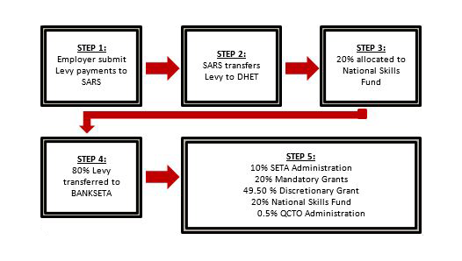
- to employ persons who find it difficult to be employed
- To encourage workers to participate in learnership and other training programmes.
- To improve the employment prospects of persons previously disadvantaged by unfair discrimination and to redress those disadvantages through training and education
To ensure the quality of education and training in and for the workplace in order to assist:
- work-seekers to find work;
- retrenched workers to re-enter the Labour market;
- employers to find qualified employees
- To provide and regulate employment services.

