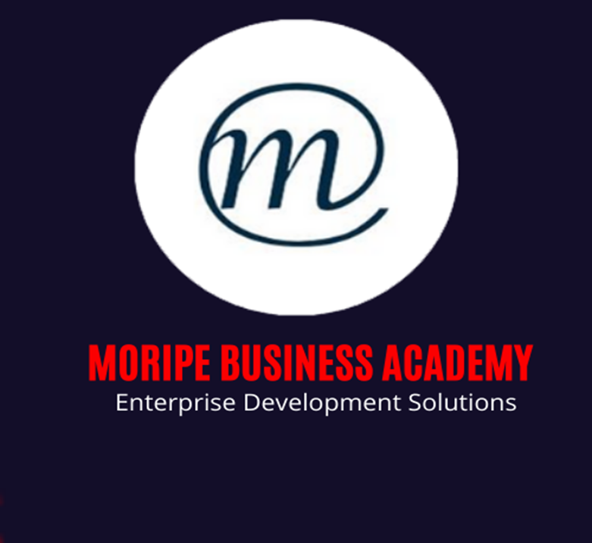
FORMATIVE ASSESSMENT

DEVELOP OWN ABILITY TO PROVIDE ADVISORY SERVICES FOR SMMEs
Unit Standard: 115830
NQF Level 5
Credits 10
Learner Information:
Learner Name:
Learner Surname:
Cell Phone Number:
Email:
Company Name:

CONTACT DETAILS

Unit Standard: | 115830
Course: | DEVELOP OWN ABILITY TO PROVIDE ADVISORY SERVICES FOR SMMEs
Assessor Details
Name
Branch |  |  | Registration No:
Contact Details | email:
Contact Details | Phone: |  | Fax:
Moderator Details
Name
Branch
Contact Details | email: |  | Registration No:
Contact Details | Phone: |  | Fax:
Candidate Details
Surname |  |  |  | Name
College |  |  |  | ID No
Branch
Contact Details | email:
Contact Details | Phone: |  |  | Fax:

CLASSROOM ACTIVITIES

- In your own words, what is a business Advisor? (4)

- Name 5 roles of a business Advisor. (5)

- Name and Explain Hierarchy of Consultation purposes. (16)

- List and explain 5 types of Small Business Advisors. (10)

- Name 5 business Advisor Skills. (5)

- Name 5 typical questions that clients need to ask in order to know if the business Advisor is legitimate? (5)

- Name 5 sources of ethical standards. (5)

- Ethics

  - What is Ethics? (3)

  - Name 2 ways which are helpful to identify what ethics is not. (2)

- What is the difference between Coaching and Consultant? (6)

Total: 55

Assessment result |  | Competent | Not Yet Competent
Assessor's Name | Solomon Moripe | Assessor's Reg no | TETA Assr13- 277
Assessor's Signature
Moderation declaration |  | Competent | Not Yet Competent
Moderator's Name | Artwell Dakamela | Moderator’s Reg. No. | TETA Mod12- 166
Moderator’s Signature

