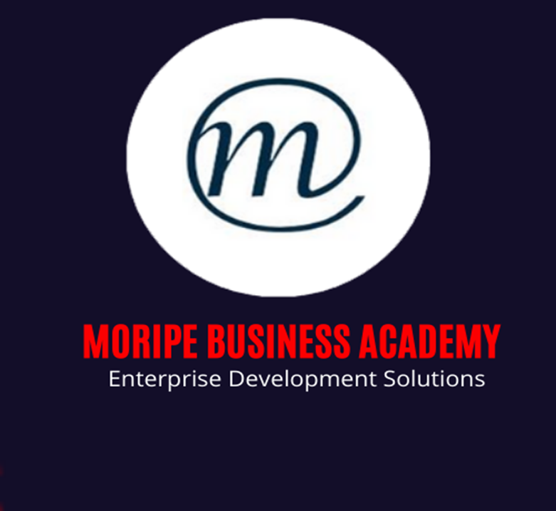

BUSINESS PLAN TEMPLATE

Unit Standard 117241
Level 4
Credits 5

Learner Information:
Learner Name:
Learner Surname:
Cell Phone Number:
Email:
Company Name:

- Executive Summary

- Company Overview

  - Introduction

  - Mission Statement

  - History and Current Status

  - Objectives

- Product and Service

  - Features

  - Benefits

  - Proprietary Rights

  - Stage of Development

- Market and Industry Analysis

  - Market Size and Growth

  - Trends

  - Target Market

  - Industry Structure

  - Competitive Environment

  - Competition

  - Opportunity

- Marketing Plan

  - Target Market Strategy

  - Channel

  - Positioning

  - Product/Service Strategy

  - Pricing Strategy

  - E-commerce

  - Communication Strategy

  - Sales Strategy

  - Revenue Model

- Operations Plan

  - Operations Strategy

  - Scope of Operations

  - Ongoing Operations

- Management

  - Company Organization

  - Management Team

- Financial Plan

  - Financial Projections

BALANCE SHEET

Assets | 2020  R | 2021  R
Current Assets

Cash

Accounts receivable

Inventory

Prepaid expenses

Short-term investments

Total current assets

Fixed (Long-Term) Assets

Long-term investments

Property, plant, and equipment

(Less accumulated depreciation)

Intangible assets

Total fixed assets

Other Assets

Deferred income tax

Other

Total Other Assets

Total Assets

Liabilities and Owner's Equity

Current Liabilities

Accounts payable

Short-term loans

Income taxes payable

Accrued salaries and wages

Unearned revenue

Current portion of long-term debt

Total current liabilities

Long-Term Liabilities

Long-term debt

Deferred income tax

Total long-term liabilities

Owner's Equity

Owner's investment

Retained earnings

Total owner's equity

Total Liabilities and Owner's Equity

Common Financial Ratios

Debt Ratio (Total Liabilities / Total Assets)

Current Ratio (Current Assets / Current Liabilities)
Working Capital (Current Assets - Current Liabilities) |  | -
Assets-to-Equity Ratio (Total Assets / Owner's Equity)
Debt-to-Equity Ratio (Total Liabilities / Owner's Equity)

INCOME STATEMENT

 |  | R
Sales |  | R
Cost of Sales |  | R
Gross Profit |  | R
Expenses |  | R
Rent

Petrol

Electricity

Bank Chagers |  | R0,00
Salaries

Net Profit / Loss |  | R
Net Profit %

CASH FLOW

CASH BALANCE |  | 2019 | 2020 | 2021
 | Date Ending
 | Cash at Beginning of Period
 | Cash at End of Period | R | R | R
CASH INFLOWS |  | 2019 | 2020 | 2021
Cash from Operations
 | Receipts from Customers
 | Gross Rents
 | Total Cash from Operations | R | R | R
Cash from Financing
 | Issuance of Stock
 | Borrowing
 | Total Cash from Financing | R | R | R
Cash from Investing
 | Sale of Property and Equipment
 | Collection of Principal on Loans
 | Sale of Investment Securities
 | Total Cash from Investing | R | R | R
Total Cash Inflows
CASH OUTFLOWS |  | 2019 | 2020 | 2021
Operations
 | Wages
 | Inventory Purchases
 | General Operating Expenses
 | Interest
 | Income Taxes
 | Totoal Outflows from Operations | R | R | R
Financing
 | Repayment of Loans
 | Repurchase of Stocks
 | Dividends Paid
 | Total Outflows from Financing | R | R | R
Investing
 | Purchase of Property and Equipment
 | Making Loans to Other Entities
 | Purchase of Investment Securities
 | Total Outflows from Investing | R | R | R
Total Cash Outflows |  | R | R | R
NET CASH FLOW |  | R | R | R

  - Key Assumptions

  - Sources and Uses of Funds

  - Business Risks

- Funding

  - Funding Requirements

  - Funding Strategies

  - Sources and Uses of Funds Statement

  - Offering

- Appendices
The appendices are where you should collect all of the documentation that supports the body of your business plan. As with the plan as a whole, it should be complete, but succinct. Include those documents that are required (financial projections), those that are helpful (results of marketing studies), and those that assist in selling your idea (letters of interest from potential customers). Don't include lots of tangential information such as newspaper clippings or tables of data unless they serve to bolster your plan. One way to deal with information that is voluminous and/or lengthy (such as a large market research study) is to summarize it, and note in the plan that the complete document is available upon request.

Required
- Key financial assumptions
- 5 year Income Statement
- 5 year Balance Sheet
- 5 year Cash Flow
- Monthly & Quarterly Cash Flow Statements
- Financial Comps
- Resumes of founders and principals

Optional
- Customer surveys and results
- Operations layout
- Sample menus, web pages, adverts, etc.
- Anything else that will help to illuminate
- and/or sell your plan

