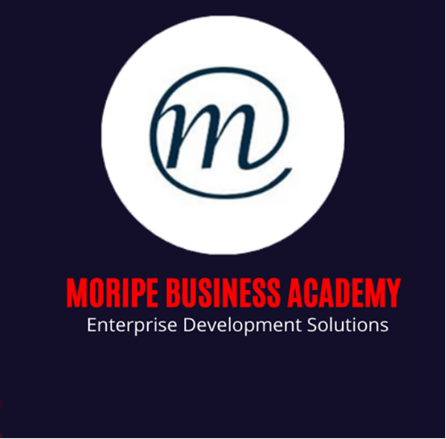

ESTABLISH AND APPRAISE THE SMME,S CURRENT SITUATION AND POTENTIAL
Unit Standard 115811
NQF Level 5
Credits 10

Learner Information:
Learner Name:
Learner Surname:
Cell Phone Number:
Email:
Company Name:
BUSINESS MODEL CANVAS QUESTIONS

KEY PARTNERS
Key partners are businesses or people that you need successful. Each should benefit from the relationship.

What key resources do they provide?

What key activities do they perform?

What might we give them in return?

KEY ACTIVITIES

What activities do our value proposition require?

For example: Operations, marketing, production, problem-solving and Administration

KEY RESOURCES

What resources do our products require?

A physical Location, distribution, brand, Human?

Revenue Streams?

VALUE PROPOSITIONS

What are all your products or services?

What do potential customers want or need?

What specific values are we supplying?

What do potential customers really want or need?

What is unique about your product?

Is the price, right?

What customer problem are we solving?

Customer Relationships

How will we get, keep and grow customers?

Why will they take us?

How can we form relationships with our customers?

Follow-ups?

Channels
How do we our customers want to be reached?

How are we reaching them now?

Separate channels for different segments?

Customer segments

For whom are we creating value?

Is it everyone or a special group (a niche)?

Consider (age, race, religion, gender, family, size, ethnicity, income, education level)

Who are our most important customers?

How would you describe them?

Where are they?

Cost Structure

What are the important and critical expenses. Look at both fixed and variable costs.

What resources are most expensive?

What activities are most expensive?

Revenue Streams

How do we make money?

How much will we make?

How are we setting prices?

Will customers pay for your products?

What are they paying now?

Are they selling products, services or both?

